**What is a firewall?  
ANS: firewall is a hardware or software security device that monitors incoming or outgoing traffic and takes a permit or deny action based on the rules configured inside the firewall.**

**Two types of rules:  
1. Implicit rules**

* **System defined**
* **Can’t be modified**

**2. Explicit**

**-> user defined**

**-> can be modified**

**Host or Network based firewalls**

**A Host based firewall can protect a single host, can monitor a single host traffic.**

**Network based firewall can protect or monitor the traffic of entire network.**

**What is zone?**

**Trustworthiness of the interface or network connected to that particular interface.**

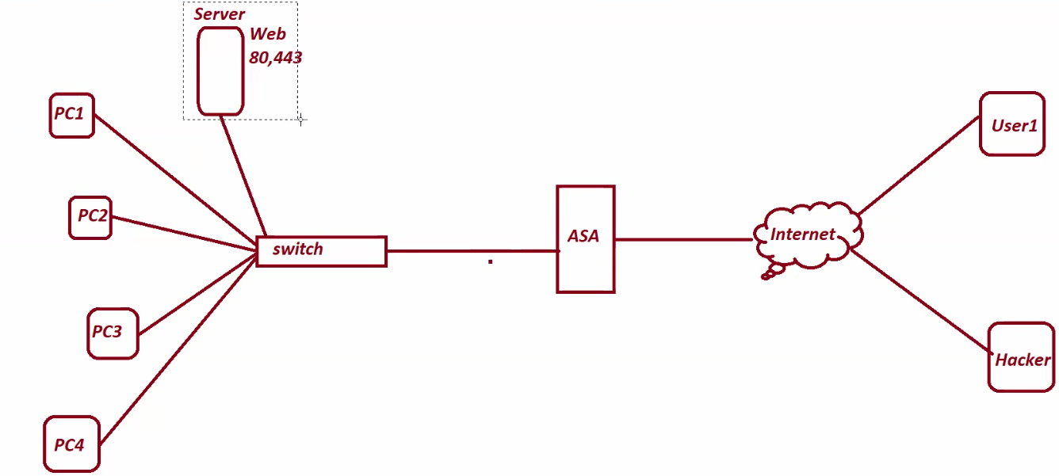

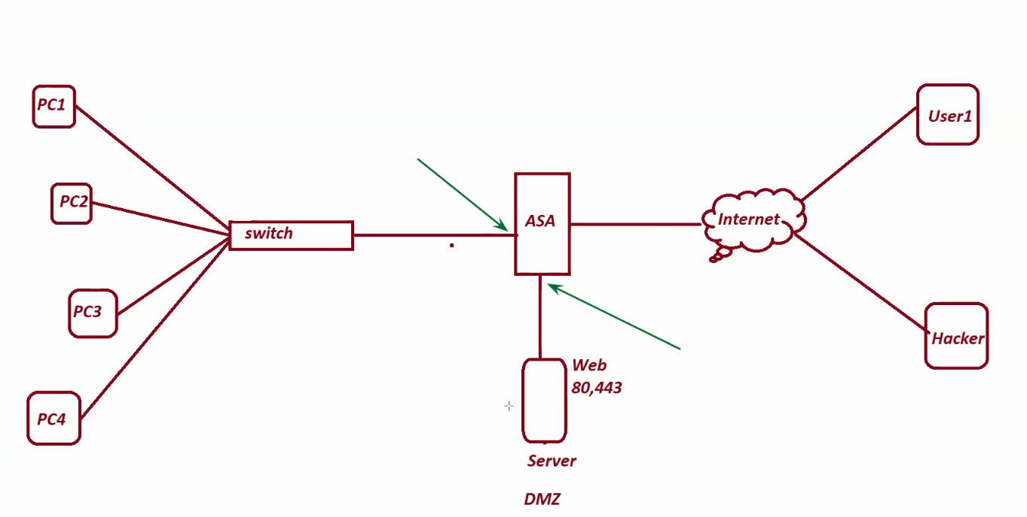

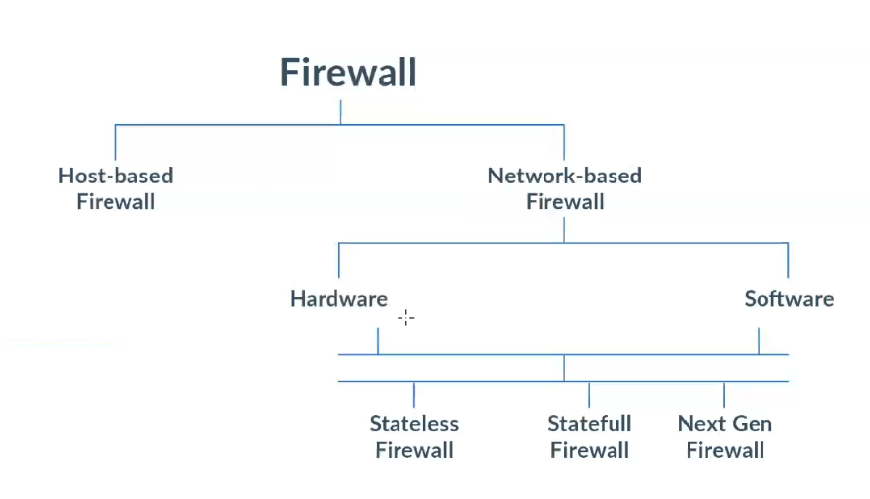

**Stateless firewall – packet filtering firewall:**

**It filters the traffic based on the ip header information in a packet like Source ip, Destination ip, and port number etc.**

**Stateful firewall – packet filtering firewall:**

**It maintains a connection table for better security. Based on the connection table entry they allow the traffic.**

**Stateful firewall = stateless + additional feature**

**Application firewall:**

**It also filters the L7(application layer) traffic.**

**It is the combination of *stateless + stateful + application* firewall.**

**Circuit-Level Gateway:**

**A circuit-level gateway is a type of firewall that filters traffic at the session layer of the OSI model.**

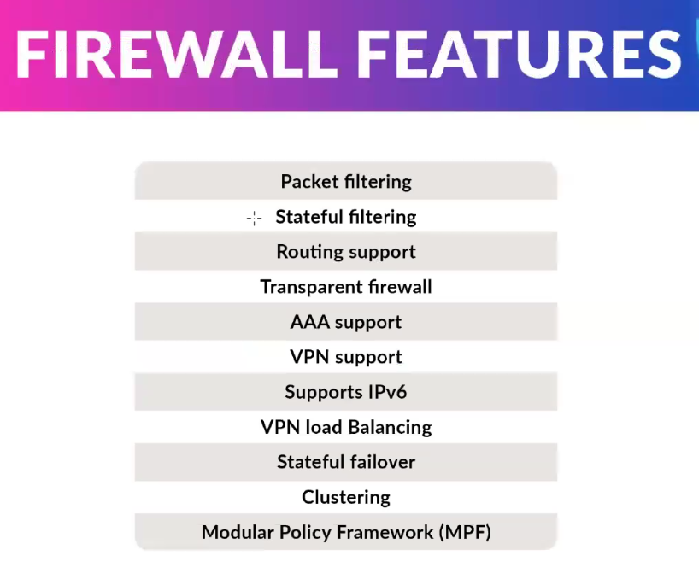

**Stateful Failover:  
Stateful failover is a feature that helps keep network connections running even if one device (like a firewall or router) stops working. It automatically switches to a backup device without disconnecting users. It remembers important connection details, so users don’t have to reconnect or start over.**

**Modular Policy Framework (MPF):  
Modular Policy Framework is a method used in firewalls (like Cisco ASA) to manage and apply different security rules in a flexible way. It helps you control things like traffic inspection, filtering, and actions (like allowing or blocking traffic) based on your needs. It's called "modular" because you can build and apply small parts (modules) of policies separately, then combine them as needed.**

**In basic steps:**

1. **Class Map – Identifies what kind of traffic you want to match (like HTTP or FTP).**
2. **Policy Map – Tells what to do with the matched traffic (like inspect or drop).**
3. **Service Policy – Applies the rule to a specific interface or globally.**

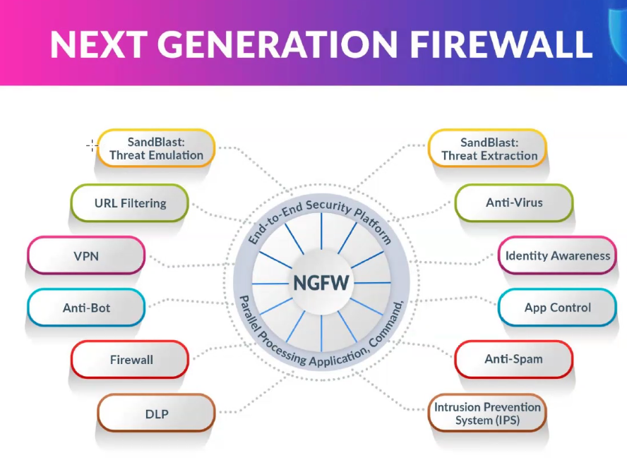

**SandBlast Threat Emulation:  
SandBlast Threat Emulation is a security feature from Check Point that helps protect your computer or network from unknown viruses and cyberattacks. It works by taking suspicious files (like email attachments or downloads) and opening them in a safe virtual environment (called a sandbox). This lets it check if the file behaves like a threat—without putting your real system at risk.**

**Anti-Bot (in NGFW):   
The Anti-Bot feature helps protect your network from infected devices (called bots) that try to connect to hackers’ servers. It detects and blocks these bots from sending data or receiving commands.**

**In basic terms:**

* **A bot is a device secretly controlled by a hacker (part of a botnet).**
* **The Anti-Bot feature watches network traffic.**
* **If it sees a device trying to talk to a known bad server, it blocks the connection.**
* **It also alerts you, so you can remove the infection.**

**✅ Why it’s useful:  
It helps stop cyberattacks like data theft, spam sending, or DDoS attacks by cutting off communication between bots and their controllers.**

**Evolution Of Firewall**

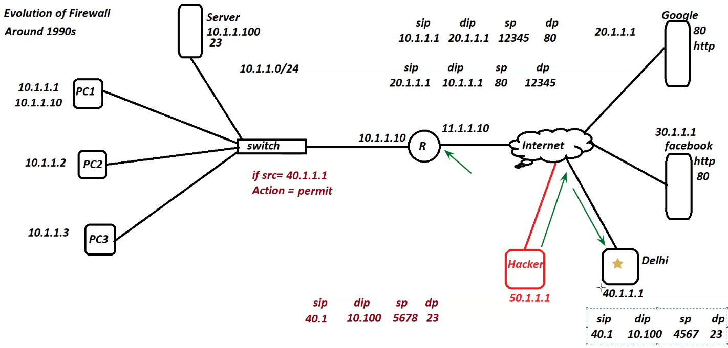

**Default Behaviour of Router allow all traffic. (Http)**

1. **1994 Cisco pix firewall  
   it doesn’t have inbuild vpn.**

**One extra vpn should be installed. (vpn 3000 concentrator)**

1. **2005 Cisco ASA**

**ASA = vpn + firewall + router**

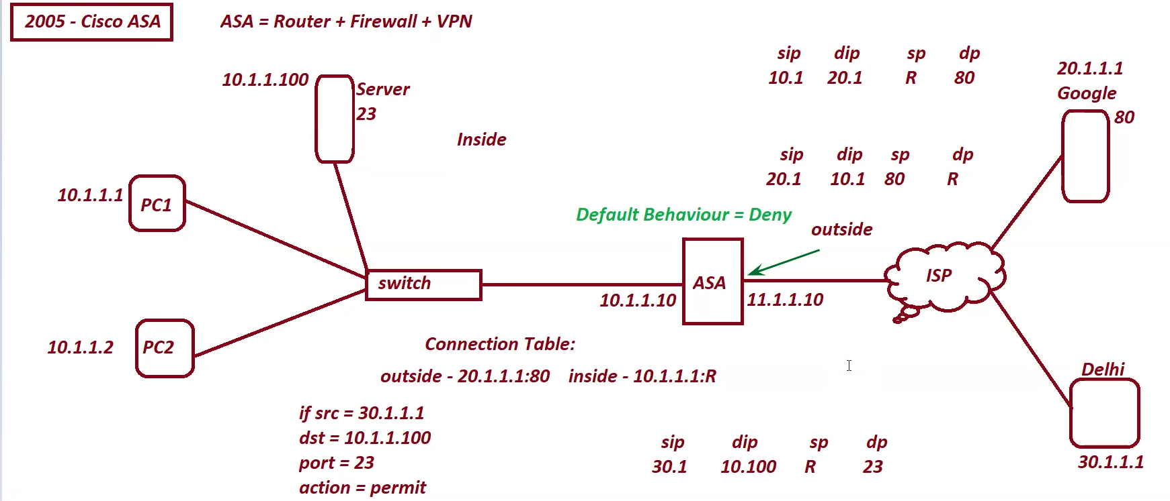

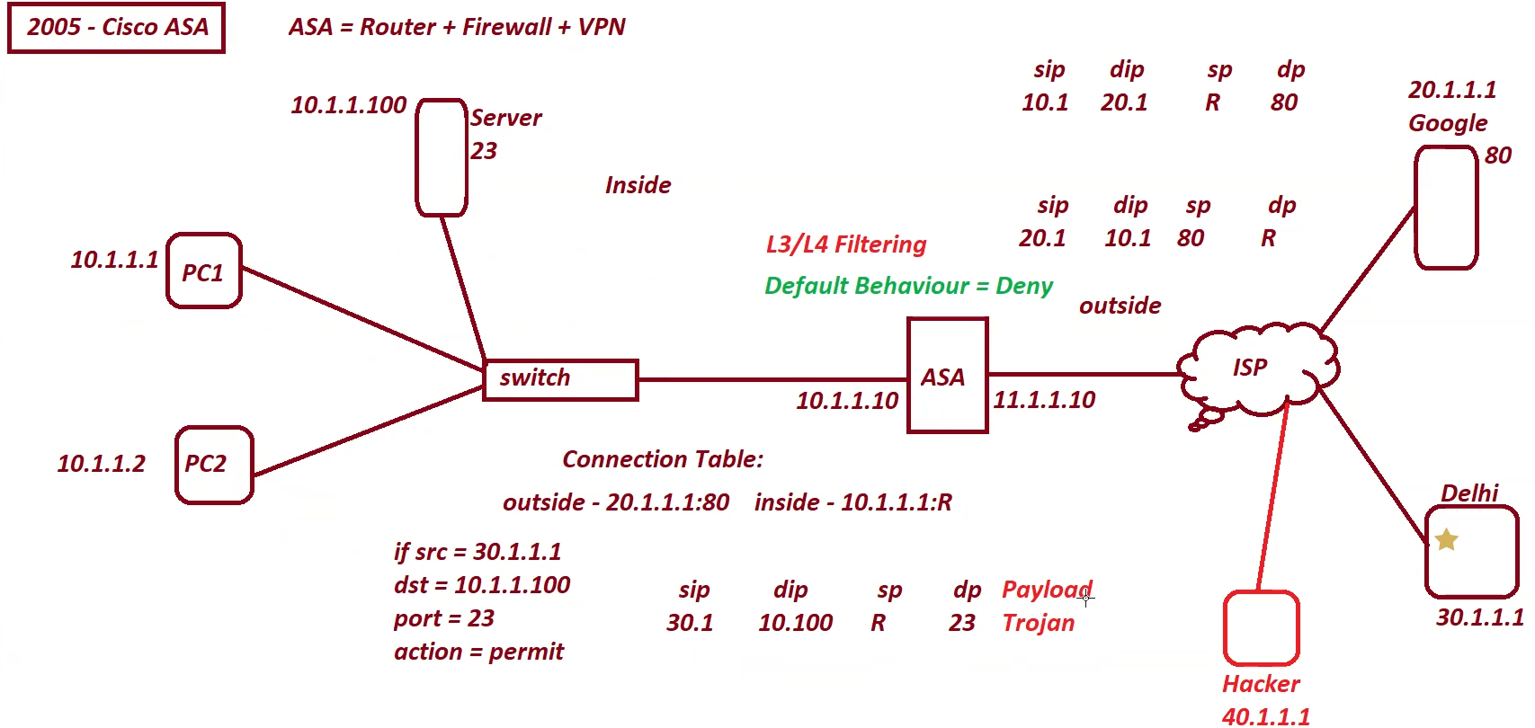

**Here the hacker can’t connect directly to trusted zone of the asa but he can access one of the pc in the delhi branch, then he will be able to send the traffic with different virus which was undetectable by ASA firewall.**

**SourceFire:  
Source fire 3d system**

**Source fire defence system  
sourcefire ngfw  
source ngips**

**2013 – cisco acquired sourcefire then changed their name:**

**Ver5:  
Firesight defence center  
Firesight ngfw  
Firesight ngips**

**Ver6:  
Firepower Management Center  
Firepower Threat Defense  
Firepower NGIPS**

**IDS – Intrusion Detection System  
can detect an intrusion and generate an alert  
can’t take action or block intrusion traffic  
IDS monitors a copy of the traffic  
deployed in parallel/Promiscous mode**

**IPS – Intrusion Prevention System  
can detect an intrusion and generate an alert  
can take action or block intrusion traffic  
IPS monitors the real traffic  
deployed in series/inline mode  
Work:   
Signature Based Detection  
Anamoly Based Detection**

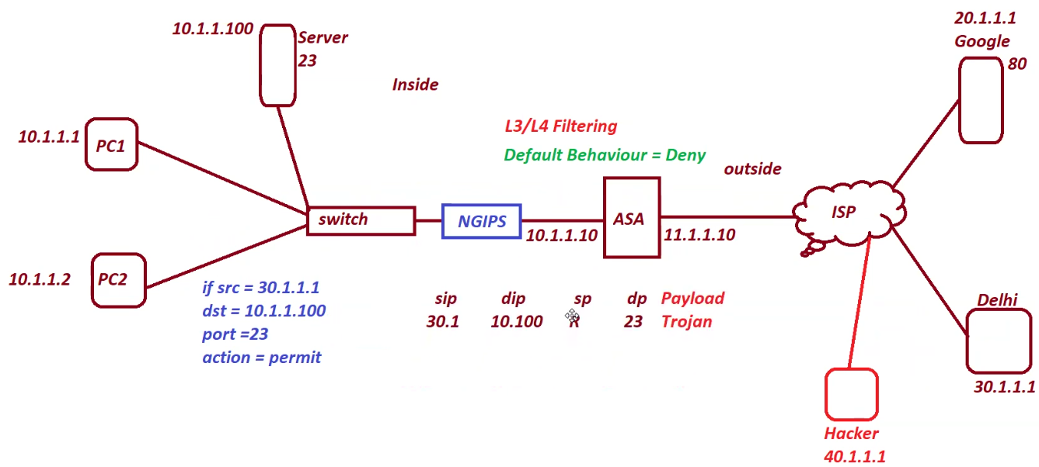

**Here ASA will allow the traffic generated by hacker using delhi branch but NGIPS checks the payload traffic where trojan house is present. NGIPS has all the list of malicious attack if it matches with the list. It will block the traffic.**

**Signature based detection  
If a person created new malware or virus which is not in ngips then it will allow the traffic.**

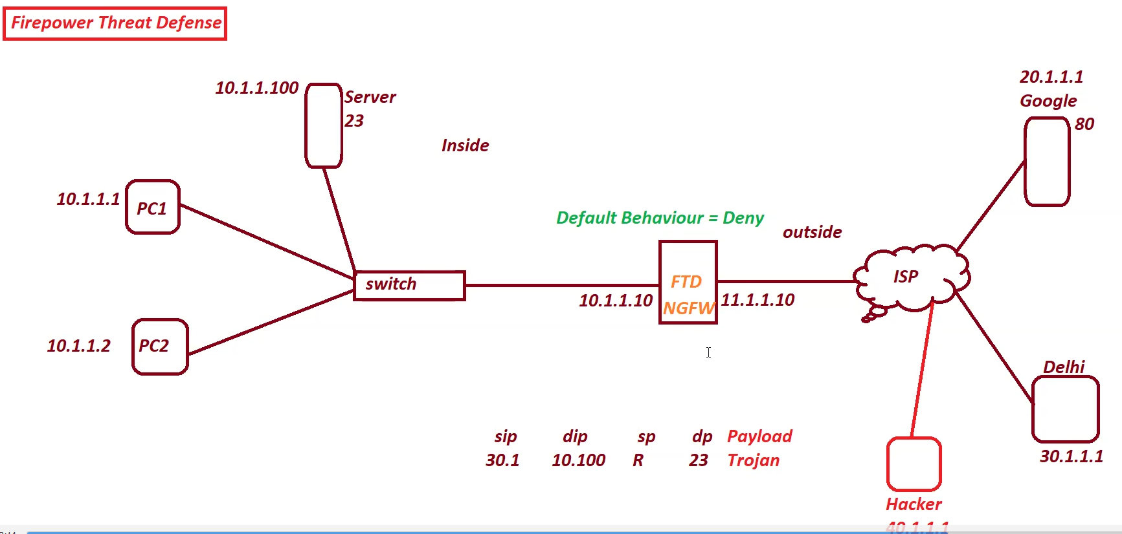

**Even if the ngips is not used in the next Generation Firewall, it uses a sandbox where it runs file in test mode environment before sending traffic to inside zone.**

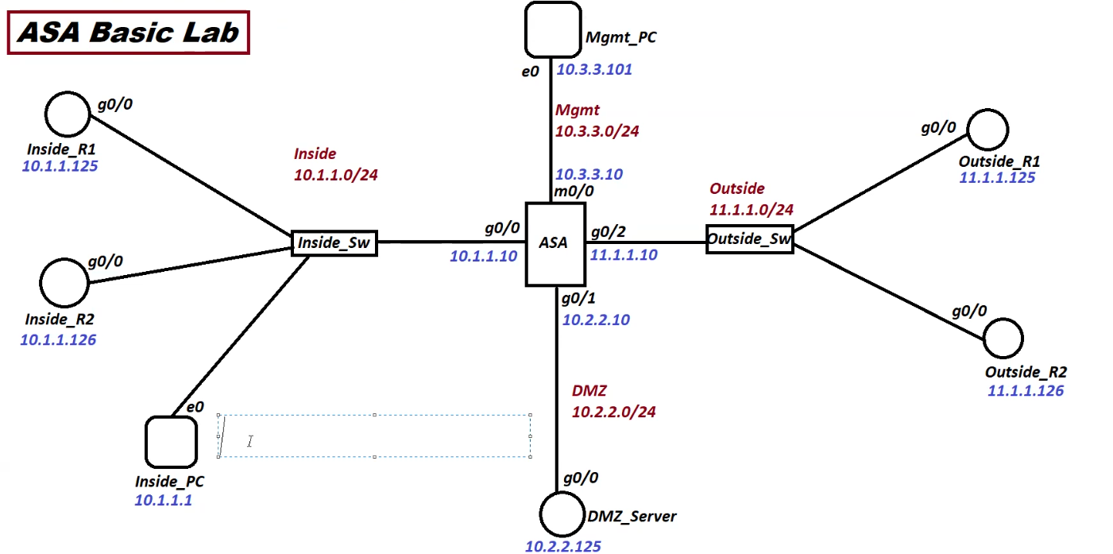

**Steps to configure firewall:  
1. Draw necessary topology, decorate and comment.  
2. Configure hostname, enable passwords, username, and password, clock and date.  
3. Configure ip address, names, and security level to the interfaces.  
4. Save and display config**

**ASA::::::**

**! Allow ping requests from inside to outside**

**access-list INSIDE-OUT permit icmp host 10.1.1.25 host 10.4.4.25 echo**

**access-group INSIDE-OUT in interface inside**

**! Allow ping replies from outside to inside**

**access-list OUTSIDE-IN permit icmp host 10.4.4.25 host 10.1.1.25 echo-reply**

**access-group OUTSIDE-IN in interface outside  
! Allow outbound Telnet**

**access-list INSIDE-OUT extended permit tcp host 10.1.1.25 host 10.4.4.25 eq telnet**

**! Allow return traffic (simplified)**

**access-list OUTSIDE-IN extended permit tcp host 10.4.4.25 eq telnet host 10.1.1.25**

**! Apply ACLs**

**access-group INSIDE-OUT in interface inside**

**access-group OUTSIDE-IN in interface outside**

**Default Inspection:**

**ASA allows everything from inside to outside and only tcp and udp inspection is there  
  
service enabled by default on an ASA interface**

**On an asa interface only ICMP is enabled by default.**

**Firewall Modes:**

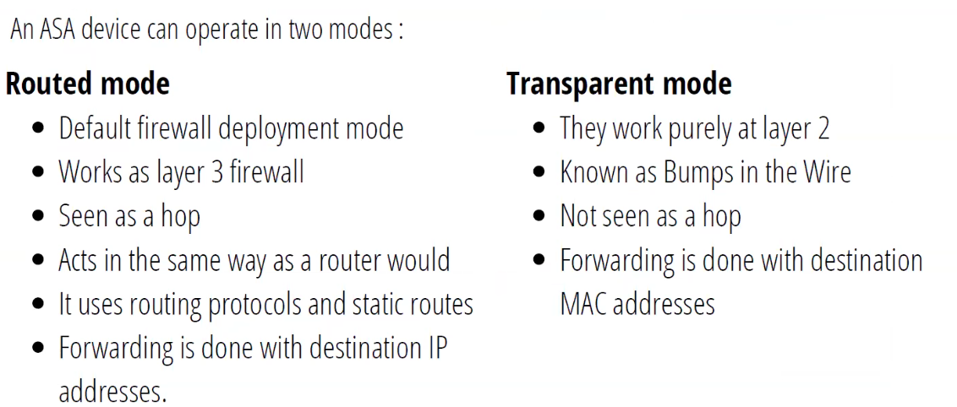

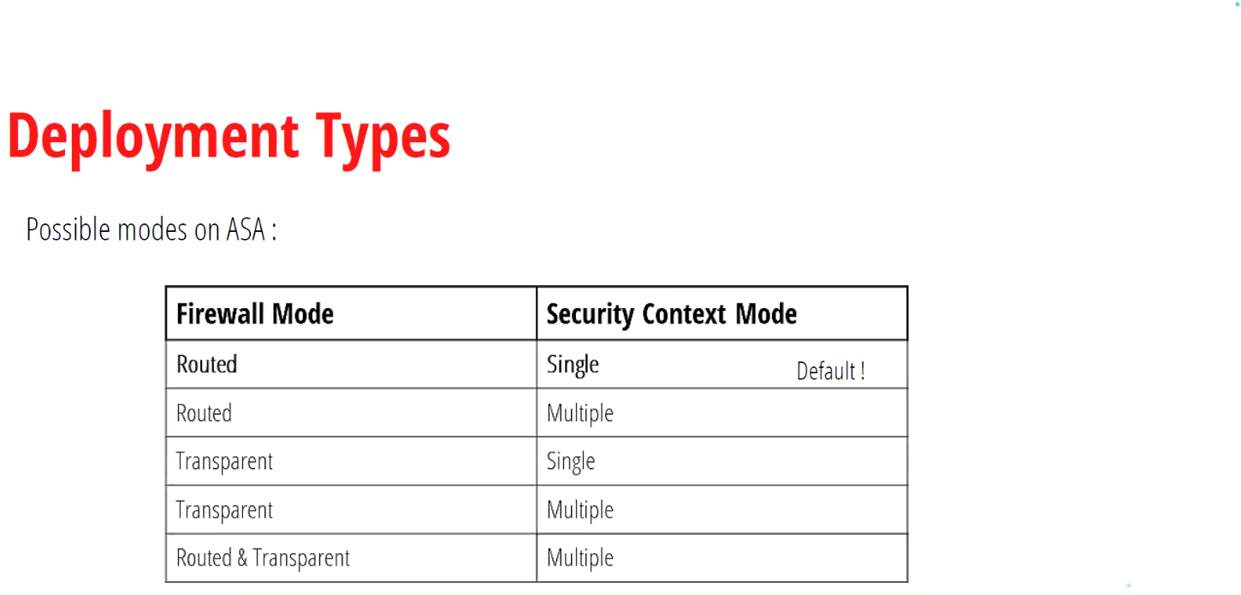

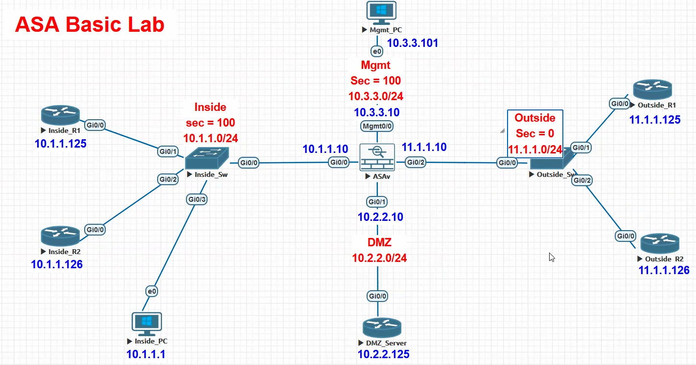

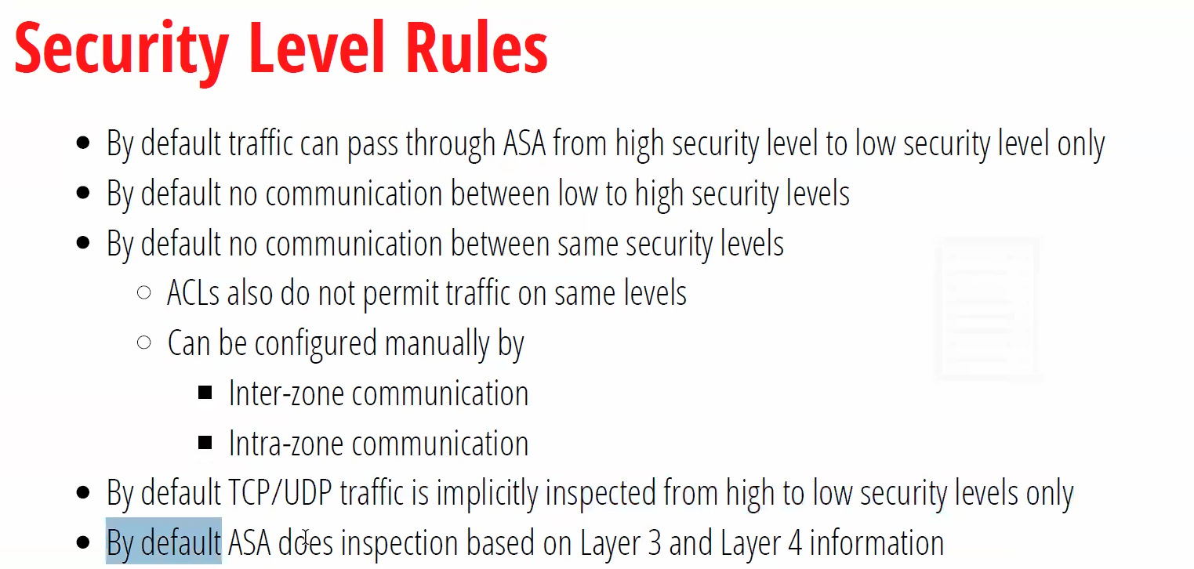

**same-security-traffic permit inter-interface  
✅ It allows traffic between two interfaces that have the same security level.  
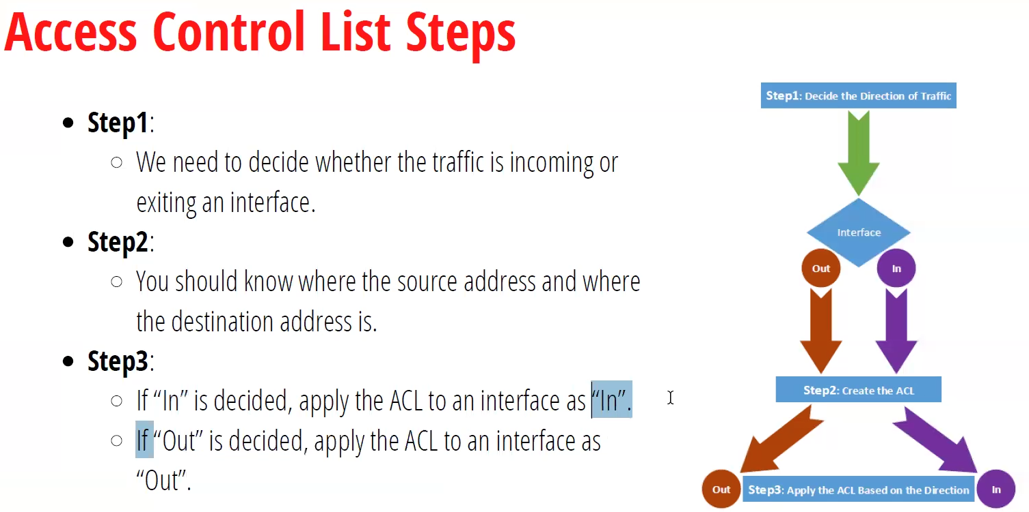**

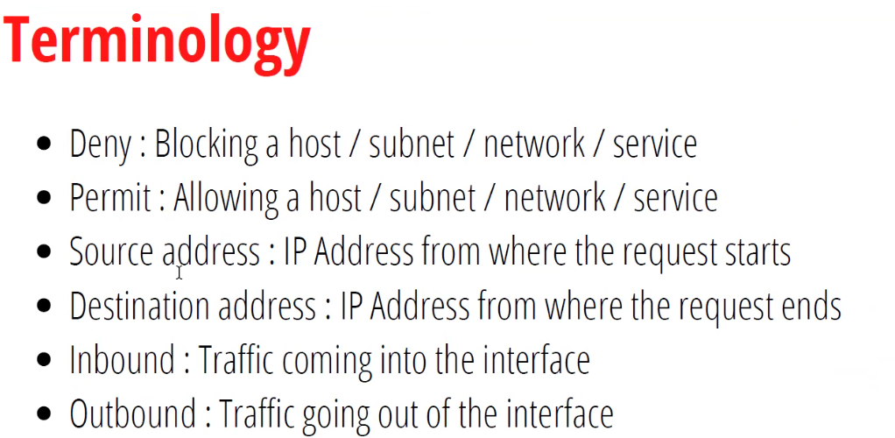

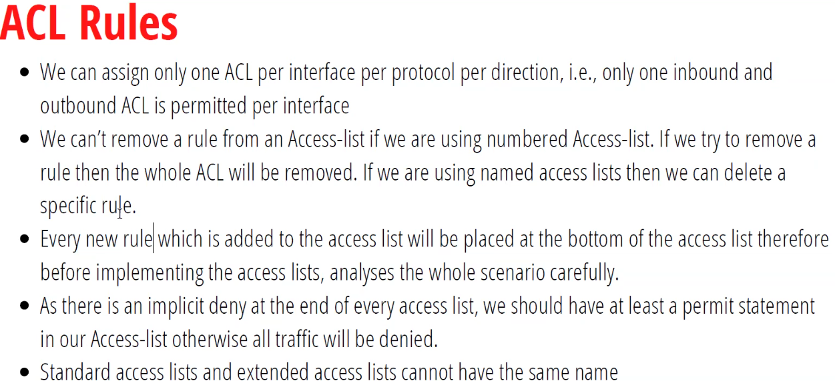

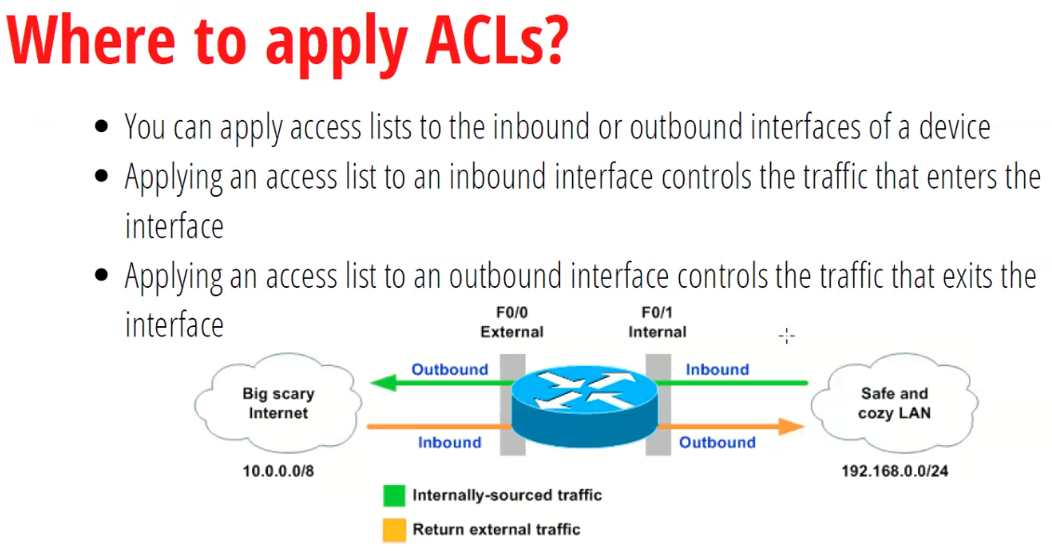

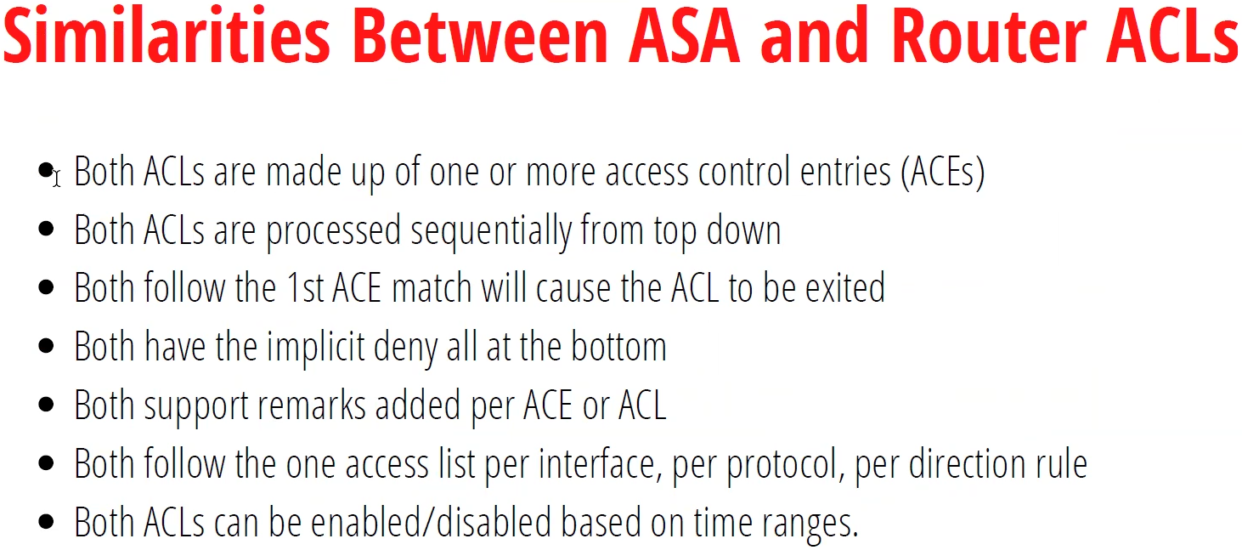

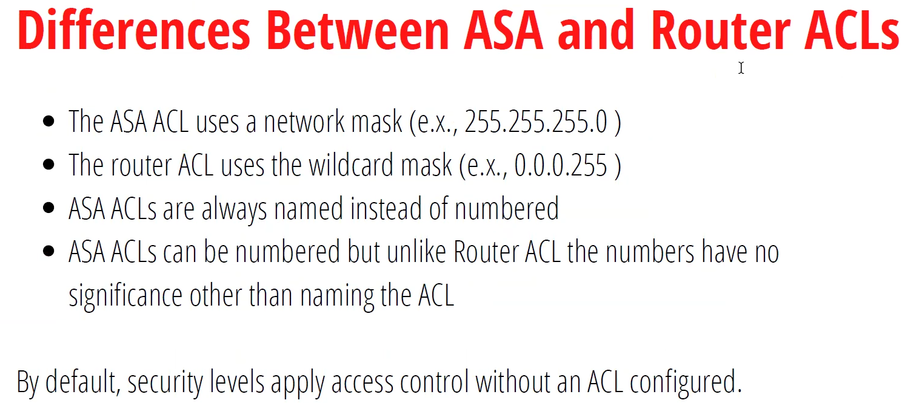

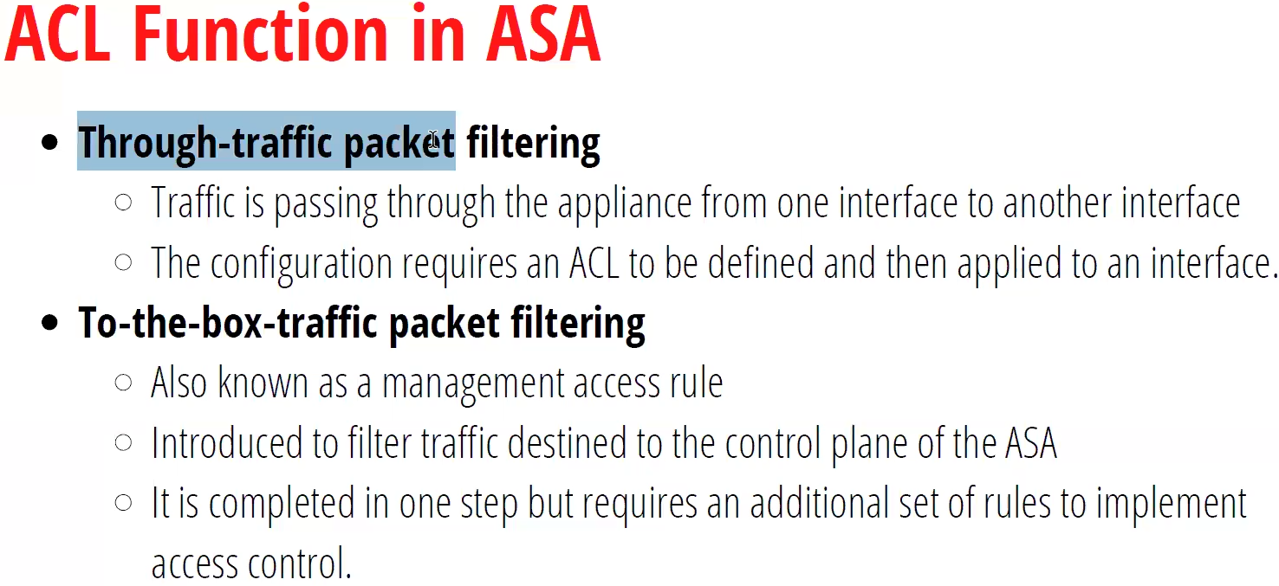

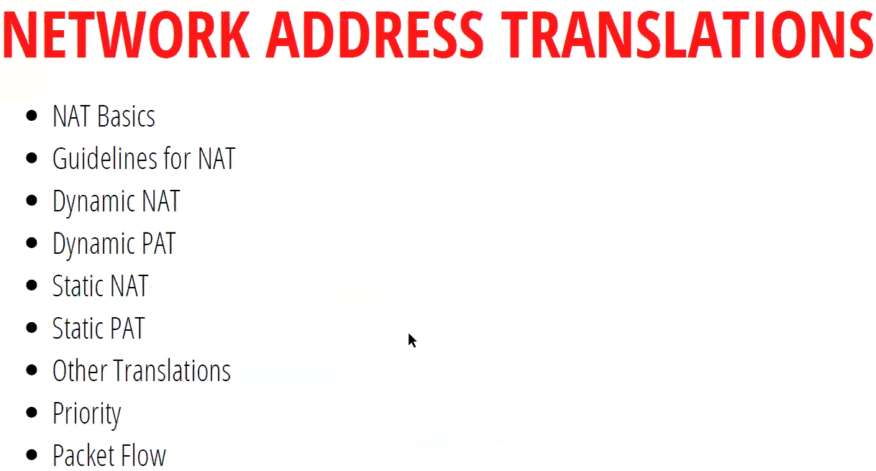

**The default connection timeout for icmp is 2s.**

**IN-DMZ line 3 extended …..  
clear configure access-list  
clear configure all**

**Day 7:**

**Controlling through traffic**

* **Control the traffic that is passing through asa**

**Controlling traffic to asa**

* **This is the traffic to the asa**

**To traffic:**

**access-list OUT-IN deny icmp host <source-ip> host <dest-ip> echo  
access-groups OUT-IN in interface outside  
  
icmp deny host <source-ip> echo <outside/inside/dmz>  
  
  
**

**Any router device remotely access ASA (telnet):  
asa(co)# telnet 10.1.1.1 255.255.255.255 outside**

**password <psd>**

**aaa authentication telnet console LOCAL  
  
or**

**asa(co)# telnet 10.1.1.1 255.255.255.255 outside**

**username <uname> password <pwd> pri 15  
aaa authentication telnet console LOCAL**

**SSH remotely to asa:**

**On asa:**

**Ssh <source-ip> 255.255.255.255 outside**

**domain-name cisco.com**

**crypto key generate rsa modules 1024**

**device used to access remotely to the asa:  
ssh -l cisco <asa-interface ip>  
Note:  
Q. What are the services are enabled on an ASA interface by default?**

**Q. What services can be enabled on the lowest security level interface of an ASA?  
ans: no one from outside interface can access the telnet but using ssh is possible.**

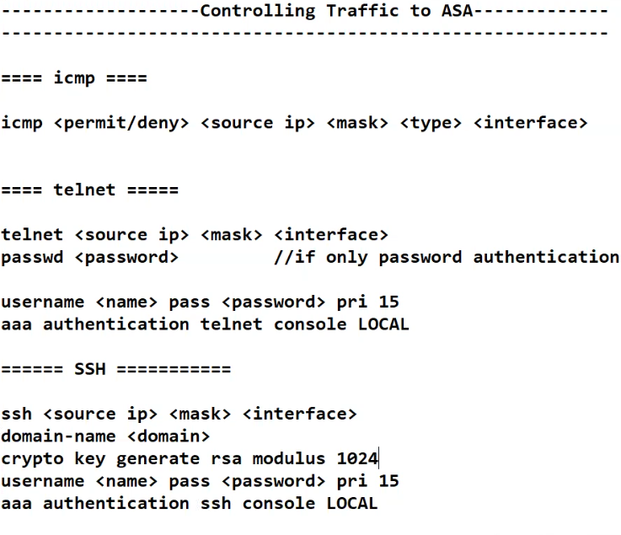

**Can’t be enabled on outside interface**

**======= HTTPS =========**

**Asa doesn’t allow http access, it only allows https access.**

**http server enabled  
http <source-ip> <mask> <interface>  
username <name> pass <password> pri 15  
aaa authentication http console LOCAL**

**-- when we take https access of ASA  
-- ASA allows us to download a java-based management application known as ASDM (Adaptive Security Device Manager).  
-- It is a java based applications that is used to manage the ASA firewall graphically**

**DAY-8: ASA backup and restore and static nat, dynamic nat and dynamic pat**

**Local backup**

* **Backup to flash memory**

**Remote backup**

* **Backup to tftp server**

**Commands:**

**Show flash**

**Local backup: copy running-config flash   
solar winds tftp   
  
remote host? <ip-address>  
  
ASA(co)#  
copy tftp flash**

**Host: <tftp-server-ip-address>**

**<filename>  
  
copy from tftp to running-config:  
copy tftp startup-config**

**Copy flash to tftp   
copy flash: tftp  
  
image boot local backup:  
Copy boot/---.bin flash  
  
  
  
  
  
  
  
  
  
  
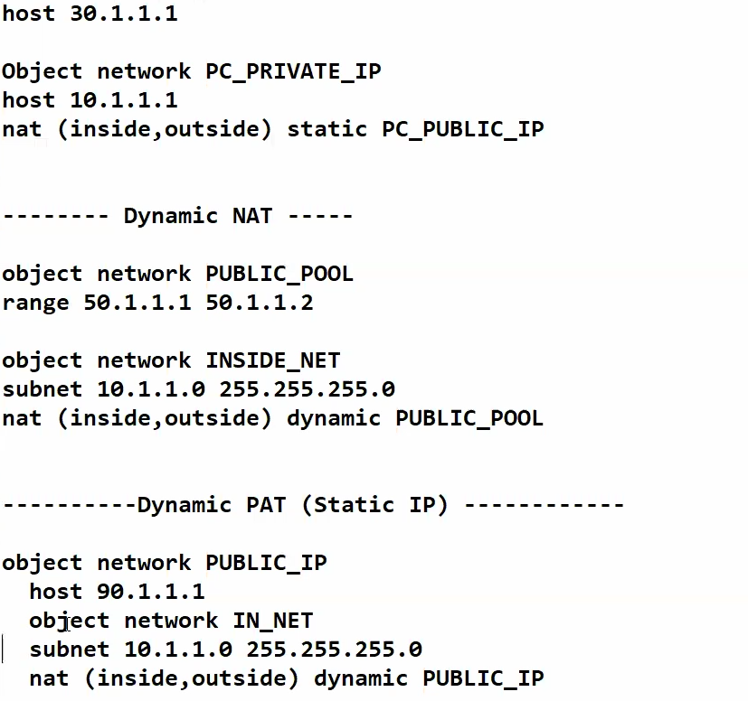  
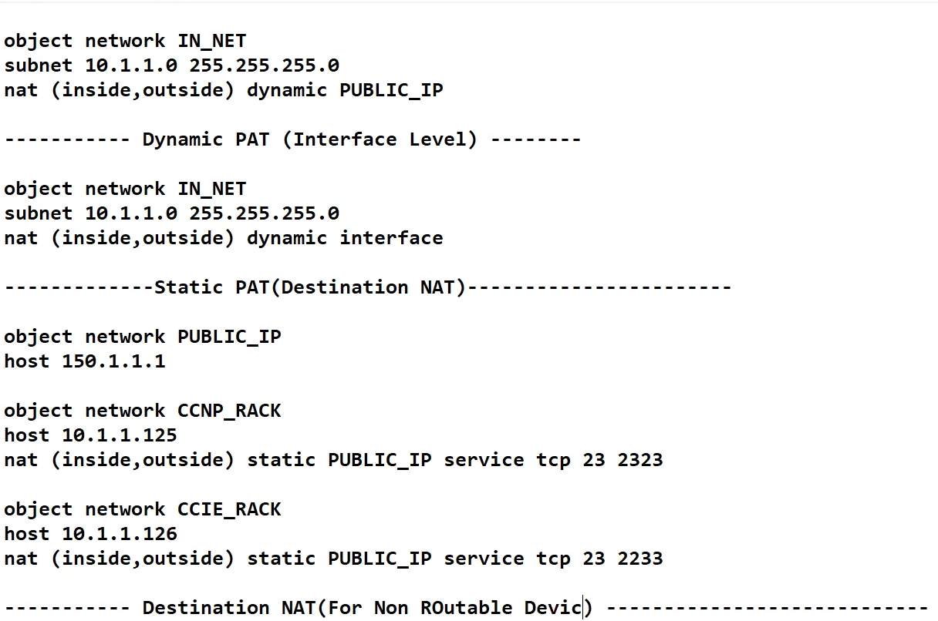**

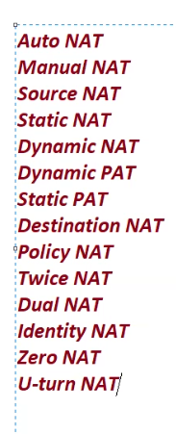**Why does NAT exist?**

**Everything on internet needs an ip address  
ipv4 addresses are 32 bits.  
-> finite number of ipv4 address in the world  
-> 2^32 ~= 4.2 billion address  
-> Originally, every host was meant to have a unique IP address   
-> But we realized we would run out of IP address  
-> To extended capability IPV4 address, we use nat to translate ipv4 address into ipv6 address.  
  
-> Create a set of ip addresses that were reusable known as private ip address.  
-> private ip addresses can be reused infinitely, anywhere  
-> Remaining ip addresses are known as “Public” ip addresses  
-> NAT translates private ip addresses into unique public ip addresses  
 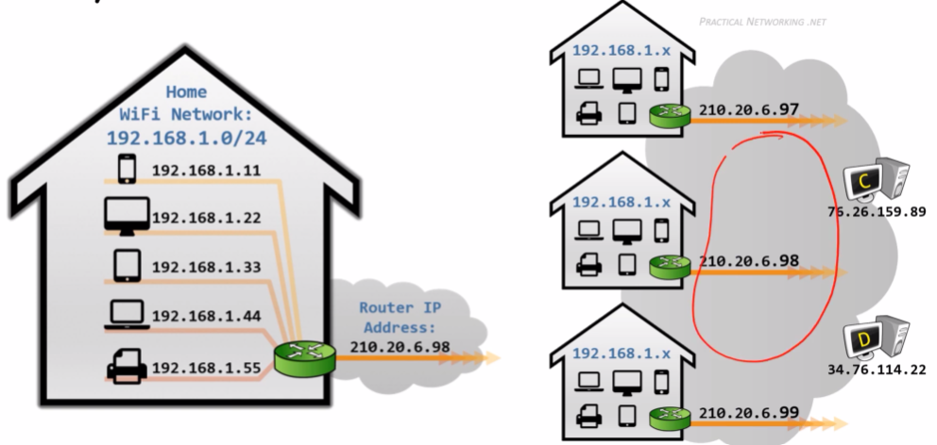**

**NAT TERMS:**

* **Types of NAT  
  static nat, dynamic nat, static pat, dynamic pat**
* **Each is a different way of Performing Address Solution**
* **Each are made up of two sets of two terms:**

**NAT VS PAT, STATIC VS DYNAMIC**

**NAT VS PAT:  
-> a packet contains data payload, L3 header, L4 header and L3 header  
L3 \ L4 \ DATA**

**-> NAT – only modifies L3 header  
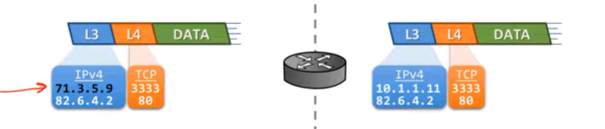**

**-> PAT – modifies both L3 and L4 header  
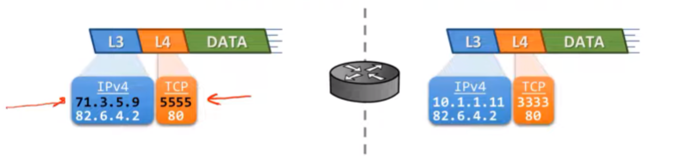**

**STATIC VS DYNAMIC:**

**-> Static – Explicit mapping between pre-translation and post-translation**

**-> Dynamic – Translation attributes selected by translation device   
NAT can be configured on firewall, load balancer, and servers.  
  
Static Nat – Explicit mapping between one ip address into another ip address  
🡪 it makes internal resources externally accessible  
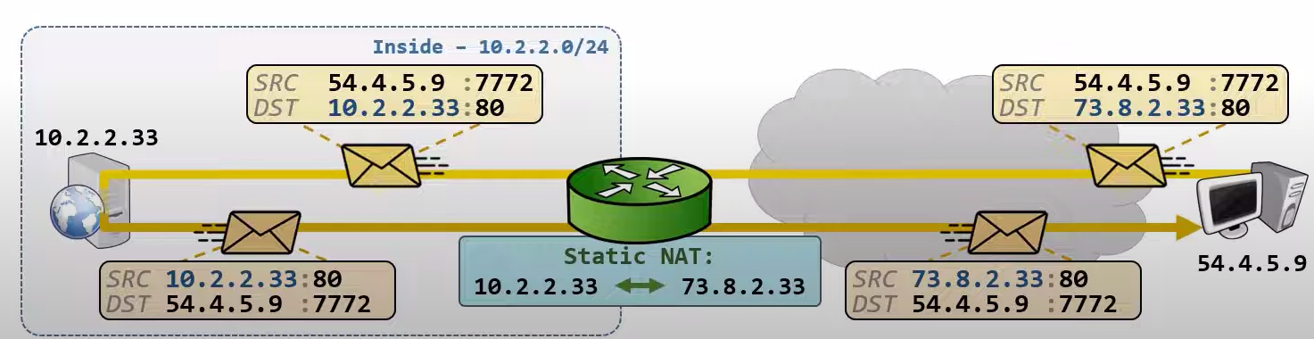  
🡪 inbound from pc to server, destination is translated  
🡪 outbound from server to pc, source is translated   
🡪 packets are translated whether initiated by internal or external host  
( Static Nat is bidirectional )  
🡪 it doesn’t conserve any ip addresses on the internet  
  
  
STATIC PAT:  
An explicit mapping between an IP:PORT to another IP:PORT  
🡪 STATIC PAT makes internal resource ports externally accessible   
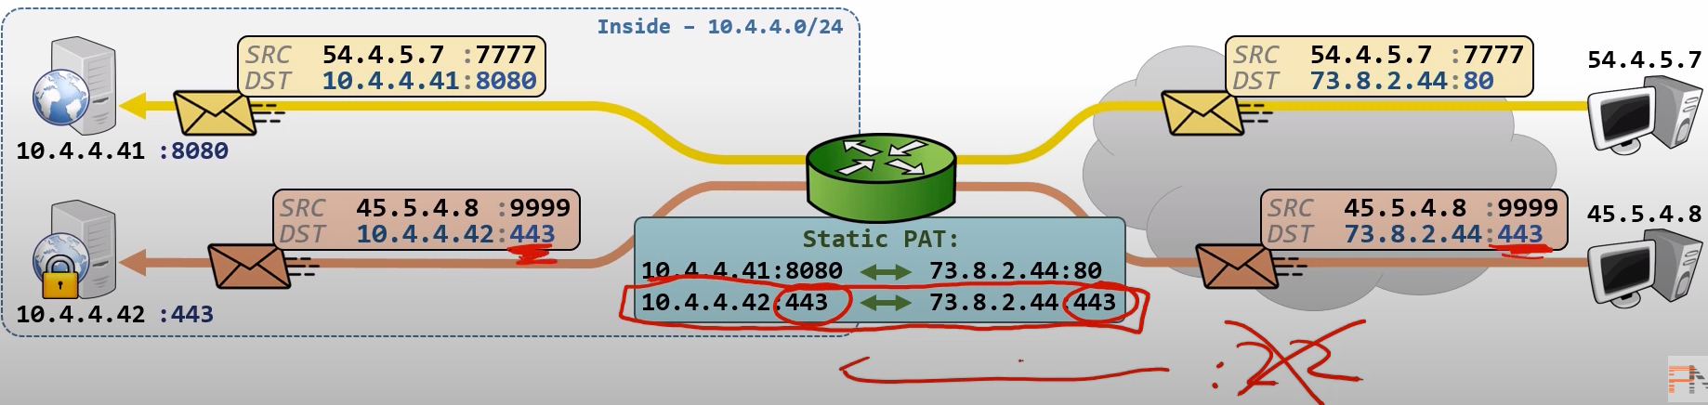  
🡪 Facilitate using non standard ports  
site.com:8080 , It is not possible to remember like destination side port no  
instead we can use source port translation. If the port is 80 then translated it to 8080**

**🡪 port forwarding / Hole punching**

**🡪 Bidirectional**

**🡪 Multiple servers can use one public ip address  
  
DYNAMIC PAT:  
🡪 Admin defines set of pre and post translation attributes  
🡪 Device determines actual post-translation ip address and port  
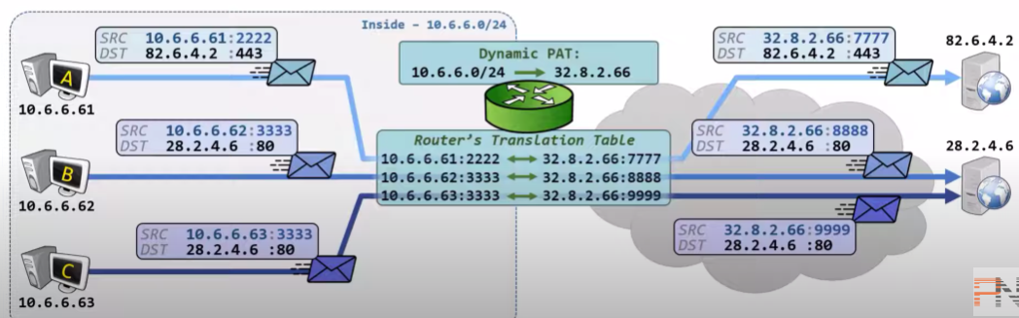**

**(this shows outbound traffic created by request of initiator)  
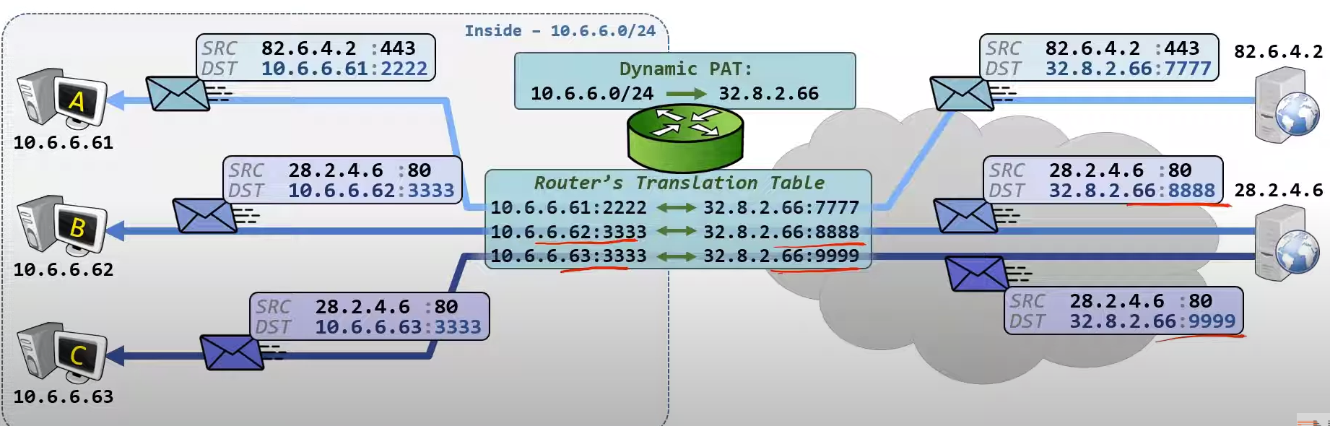**

**The traffic on translation tables are changed into different randomly generated ports.  
Q. why a random port gets translated into another random port and saved in the translation table?  
ans: to reach the initiator of the packet  
Q. What if traffic was initiated by the Outside host?  
ans: Traffic is dropped because no translation entry exist  
  
🡪 dynamic pat is unidirectional – traffic must be initiated from inside   
🡪 If we want communication then we should create a static pat that maps sever ip (port) to pc ip (port)  
NOTE: Each shared public ip allows ~65000 concurrent connections  
 Can use multiple Public Ips into allow more than ~65000 connections  
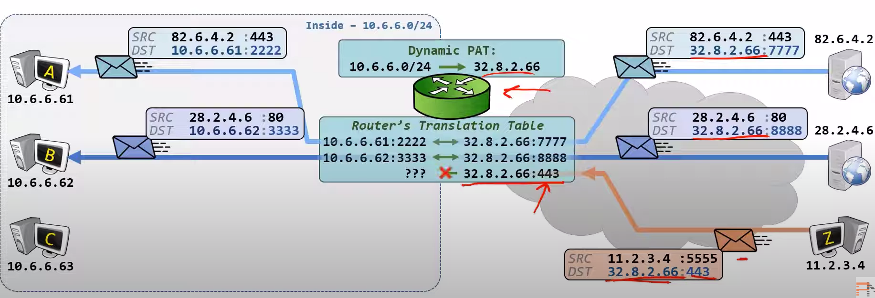  
  
  
DYNAMIC NAT:  
Admin define set of pre and post translation attributes.  
Device determines actual post-translation IP Address.  
It   
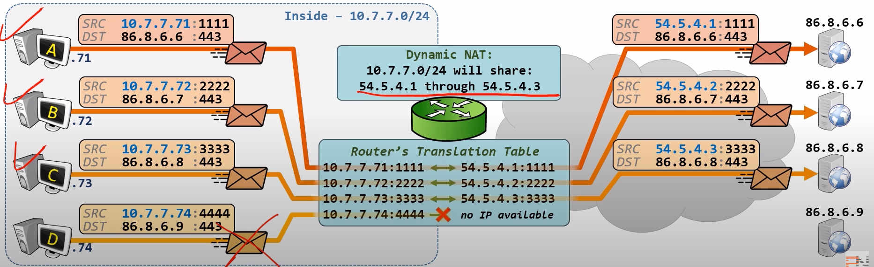  
If the host A completed his task and turn off wifi on his mobile then the device D can use the released ip.   
If the connection exist then any device outside the network can connect to that public ip.  
  
POLICY NAT:  
🡪 Every type of nat done so far has one thing in common.  
🡪 Translation is based on matching the source.  
🡪 DEF: translation decision based on Matching both source an destination  
 Once matched, packets are still translated using:  
 Static Nat, Static Pat, Dynamic Pat, Dynamic Nat  
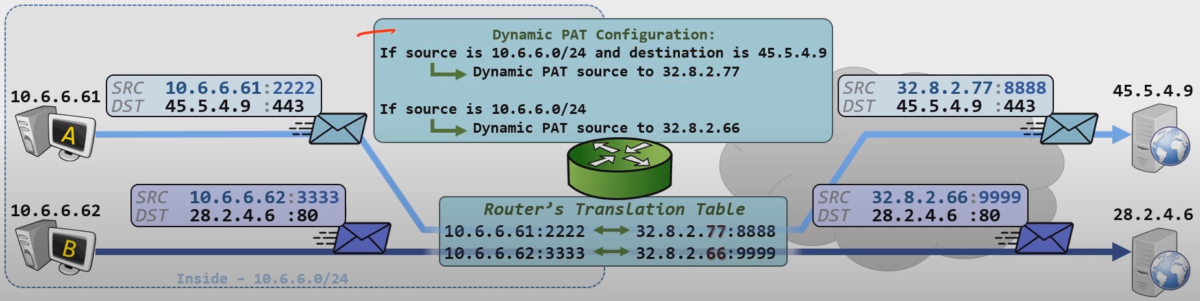**

**TWICE NAT:  
🡪 Translate both source and destination of the packet.  
🡪 Packets are still translated using:  
 static nat, dynamic nat, static pat, and dynamic pat  
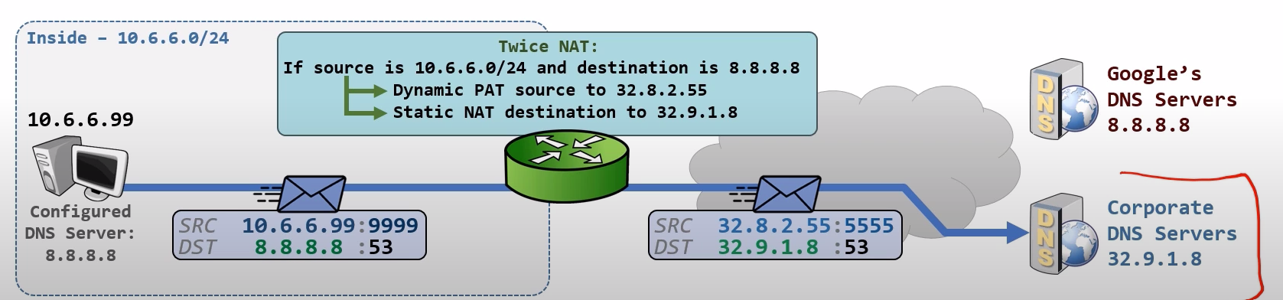  
  
  
  
🔢 NAT Rule Matching Order (Preference):**

**Cisco ASA follows this order from most specific to least:**

1. **Manual NAT (aka Twice NAT or Policy NAT) — Section 1**
2. **Auto NAT or static nat (Object NAT) — Section 2**
3. **Fallback NAT (After-auto Manual NAT) — Section 3**

**🧠 What is Identity NAT?**

**✅ Identity NAT means:**

**"DO NOT translate the IP address — leave it as it is."**

**Even though NAT is configured, you are telling the firewall:**

**“If traffic matches these conditions, no NAT needed, just let it pass with the original IP.”**

**📦 When do we use Identity NAT?**

* **For internal-to-internal communication across different interfaces.**
* **For VPN traffic (like Site-to-Site VPN tunnels — you don't want to NAT VPN packets).**
* **To bypass NAT for some trusted flows.**
* **When specific traffic must retain original IPs for security or routing reasons.**

**✏️ Example:**

**object network INTERNAL_SERVER**

**host 10.10.10.5**

**nat (inside,inside) source static INTERNAL_SERVER INTERNAL_SERVER**

**✅ This is Identity NAT.**

* **From inside to inside.**
* **Source = Destination = Same object.**
* **So ASA matches, but does not change anything.**

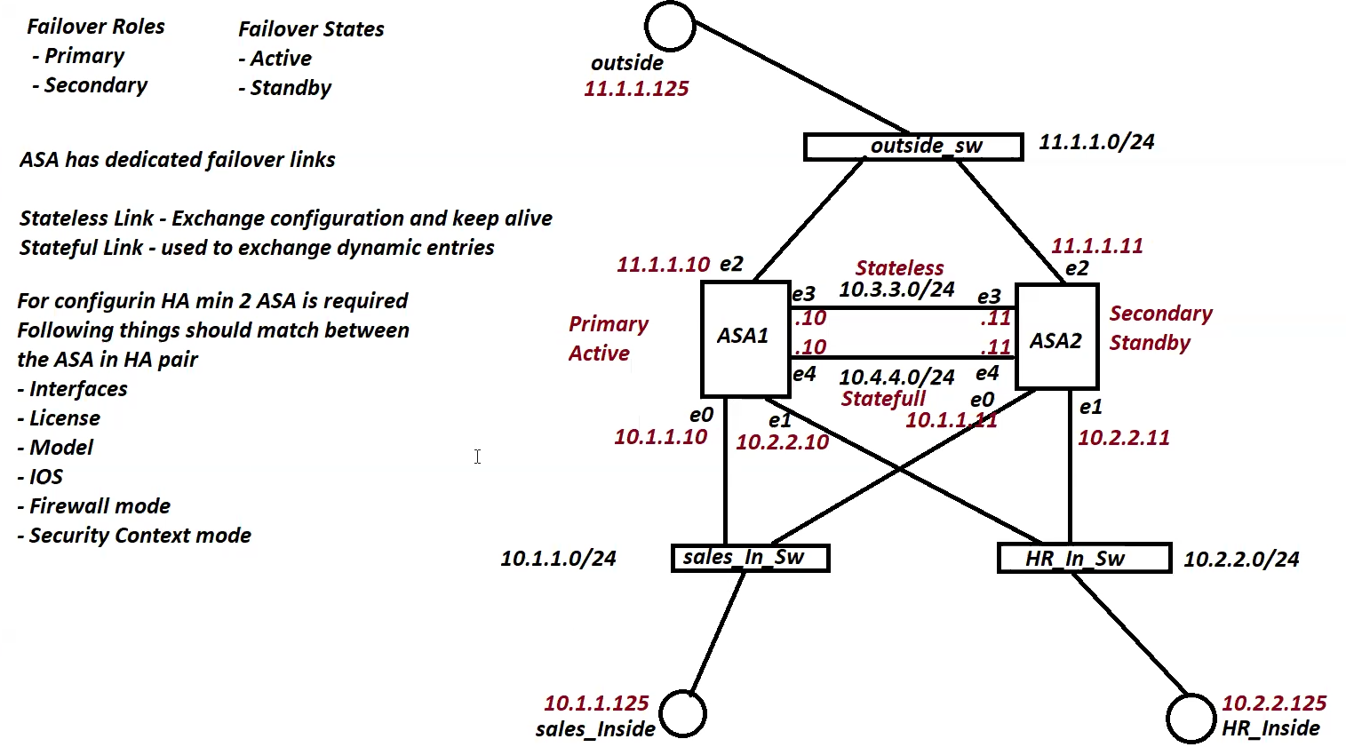

**!!!HR_INSIDE**

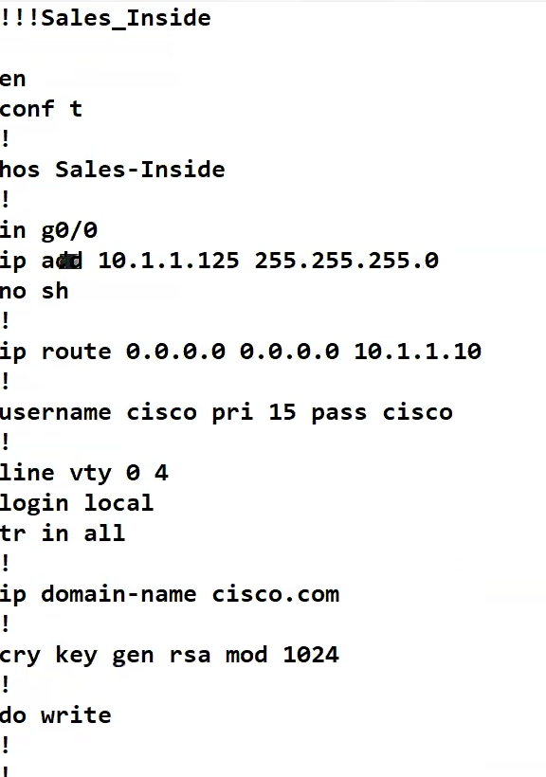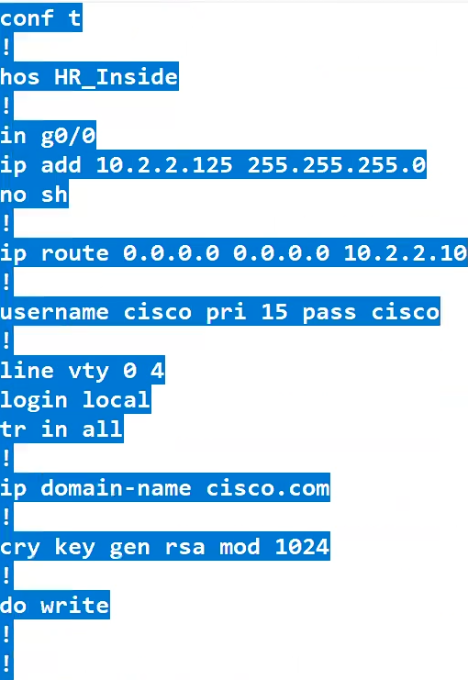

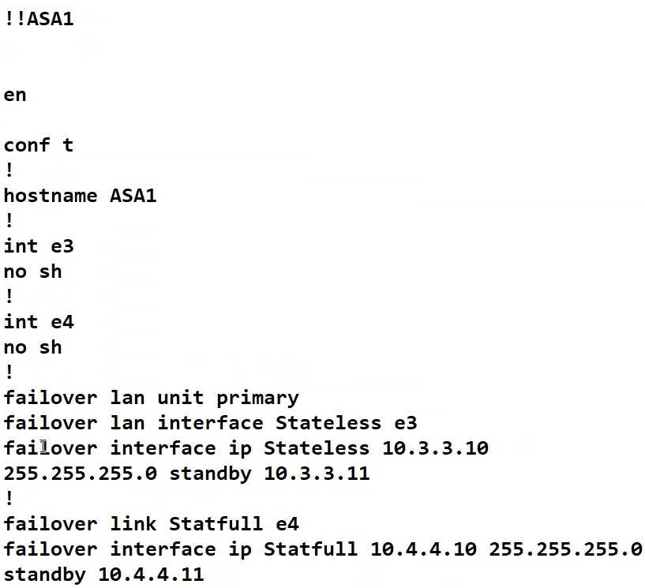

**failover**

**show failover  
show failover state**

**int e0  
nameif sales_inside  
sec 100  
ip add 10.1.1.10 255.255.255.0 standby 10.1.1.11  
no sh**

**int e1  
nameif hr_inside  
sec 100  
ip add 10.2.2.10 255.255.255.0 standby 10.2.2.11   
no sh**

**int e2  
nameif outside  
sec 0  
ip add 11.1.1.10 255.255.255.0 standby 11.1.1.11   
no sh**

**/// try to stop this asa 1 , check the failover states  
/// if you want the firewall asa1 should be active again, you should use  
failover active**

**Asa2:**

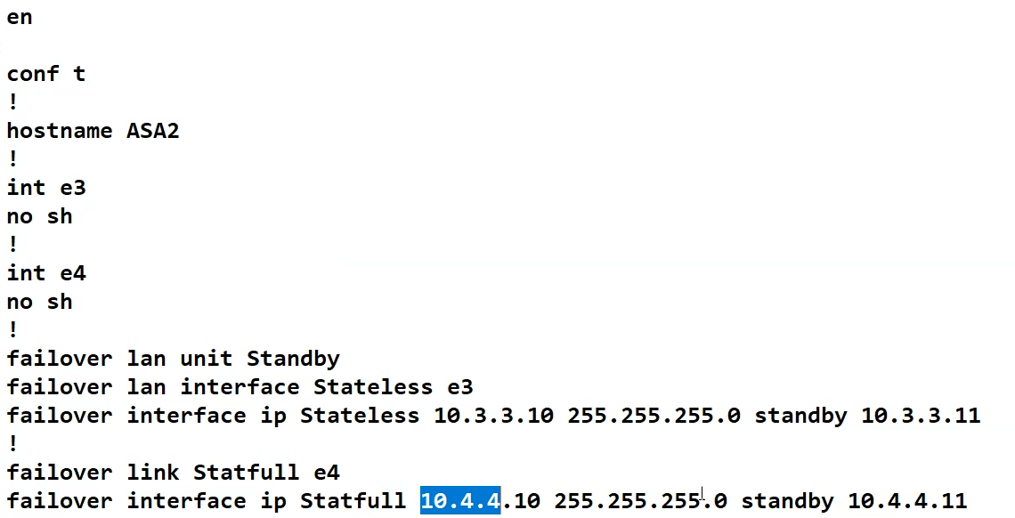

**ACTIVE ACTIVE:  
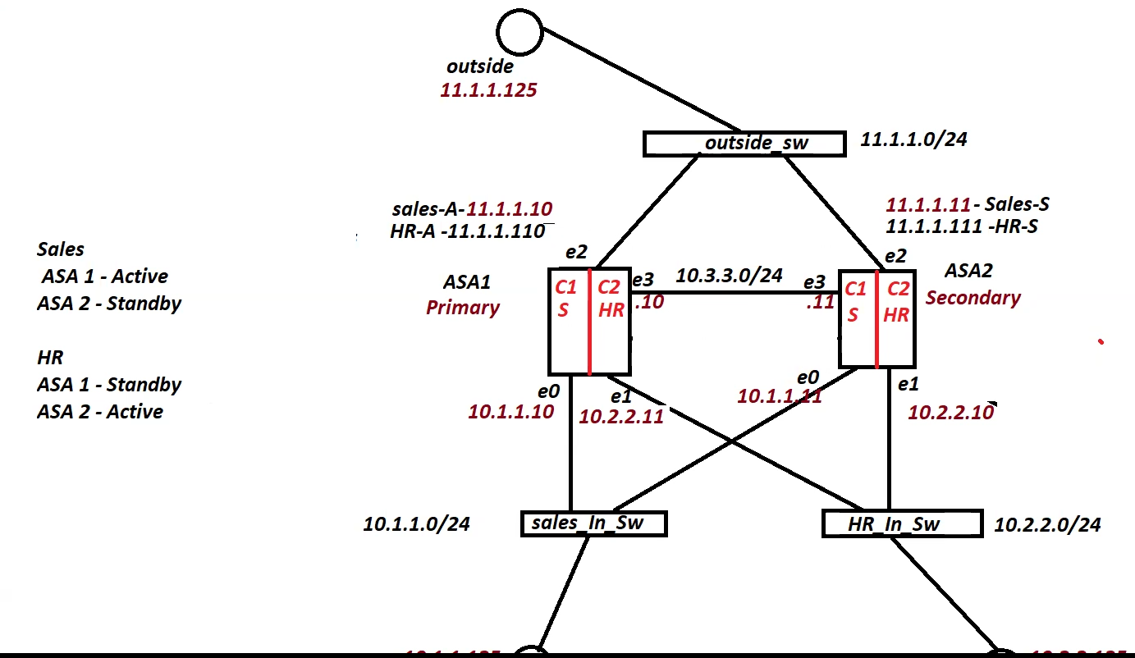**

**Only changes in the first one**

**context sales  
allocate-interface e0 INS**

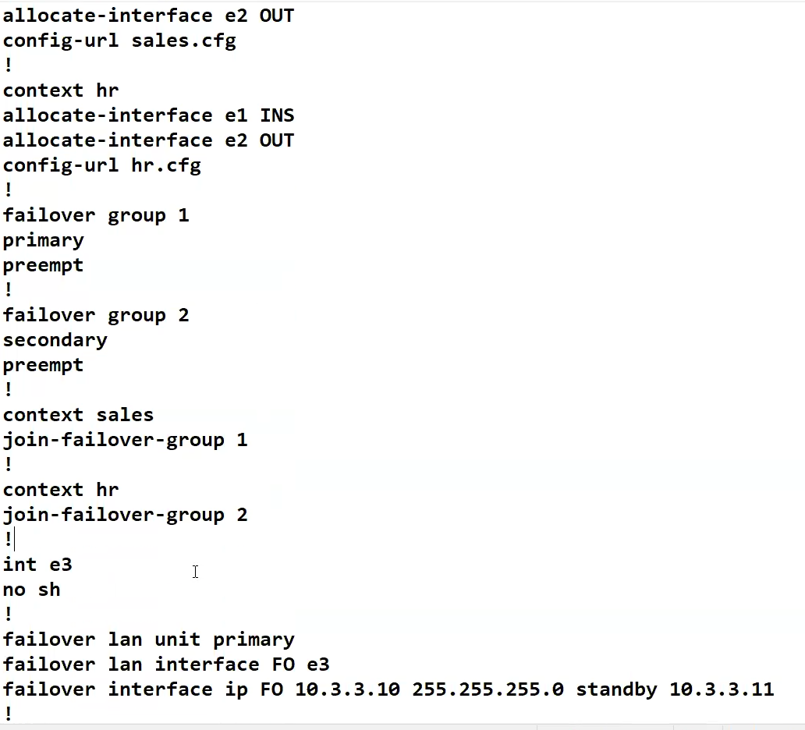

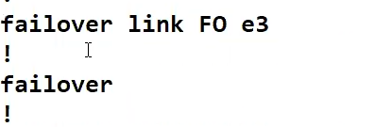

**mac-address auto**

**Configure in the changeto context in the active router  
hr-active-asa1 sales-active-asa2**

**Int ins  
nameif inside  
Ip add 10.1.1..10 /24 standby 10.1.1.11  
int out nameif outside ip add 11.1.1.10 /24 standby 11.1.1.11**

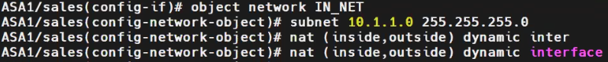

**Changeto context sales  
Sh ip int br  
fixup protocol icmp   
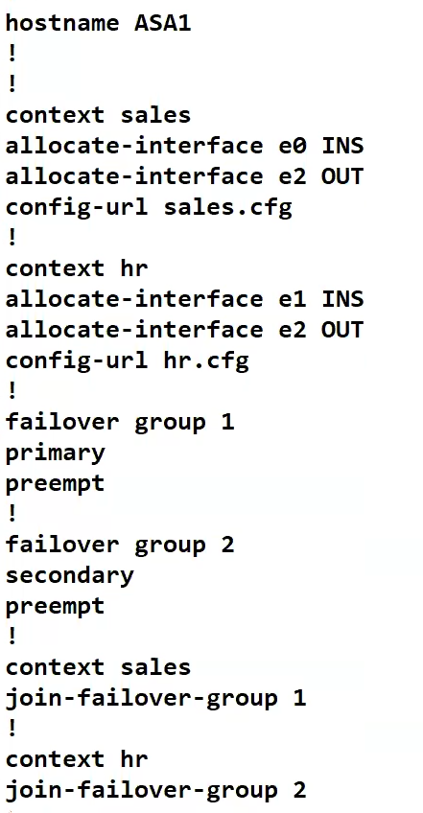**

**Same for asa2**

**changeto context hr  
  
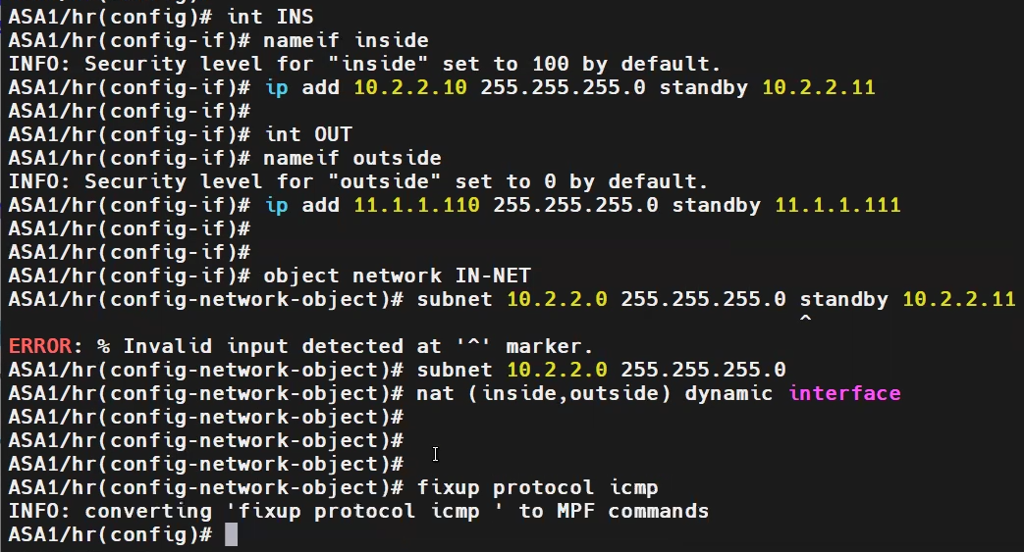**

**interface level failover:  
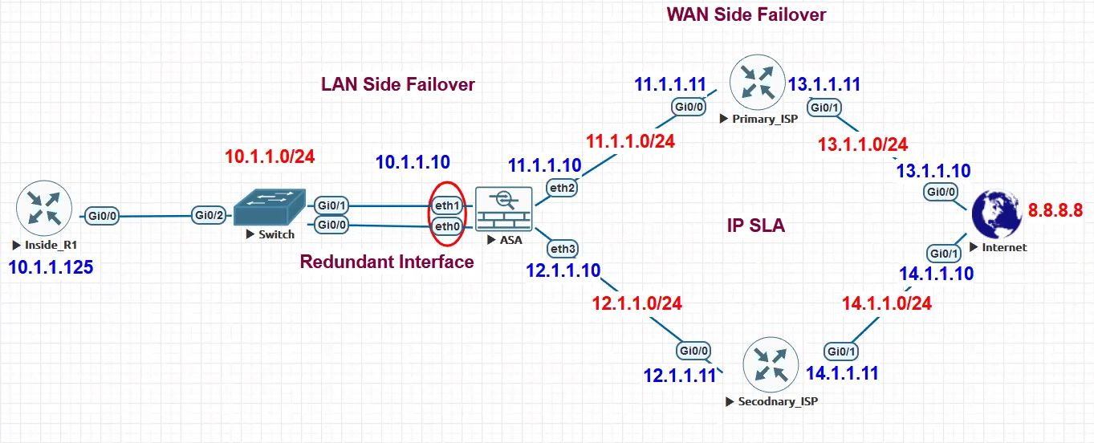**

**ASA:**

**Interface redundant 1  
member-interface eth1  
member-interface eth0  
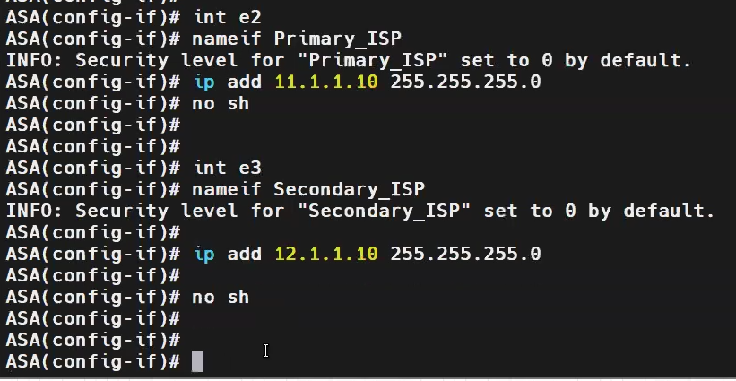**

**// if we want to configure such that, when primary goes down then only secondary should come up.**



**// but the problem is if one interface of the isp side goes down, the router doesn’t know until the data drop.**

**// instead of routing, in router , we should configure sla**

**sla monitor 100  
type echo protocol ipIcmpEcho 8.8.8.8 interface Primary_ISP  
frequency 1  
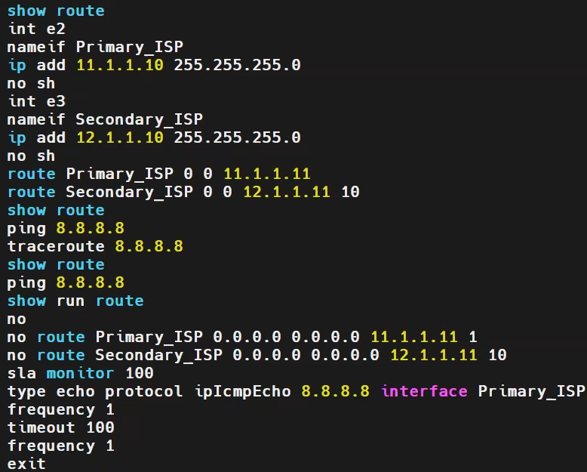  
to monitor traffic:  
sla monitor schedule 100 life forever start-time now  
RTR – response time reporter**

**track 10 rtr 100 reachability  
which route to track:  
route Primary_ISP 0 0 11.1.1.11 track 10  
when the primary is down, then it should switch to secondary:  
route Secondary_ISP 0 0 12.1.1.11 10**

**Clustering:**

**Defi: In Cisco ASA (Adaptive Security Appliance), clustering refers to the feature that allows multiple ASA units to work together as a single logical firewall.  
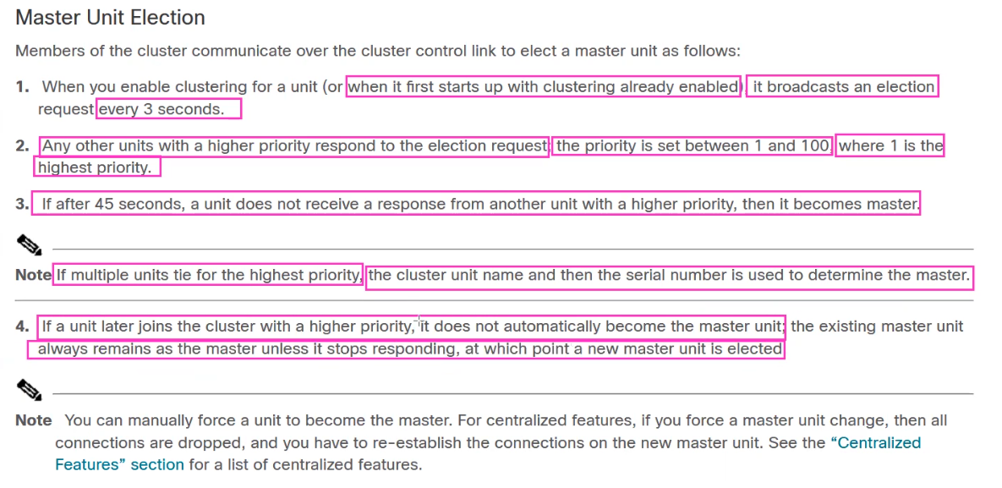**

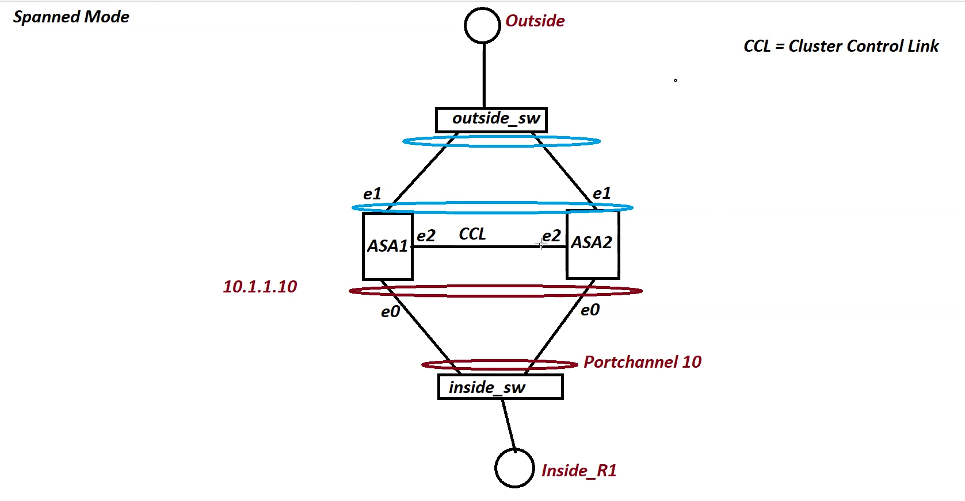

**More than 2 asa’s are present.**

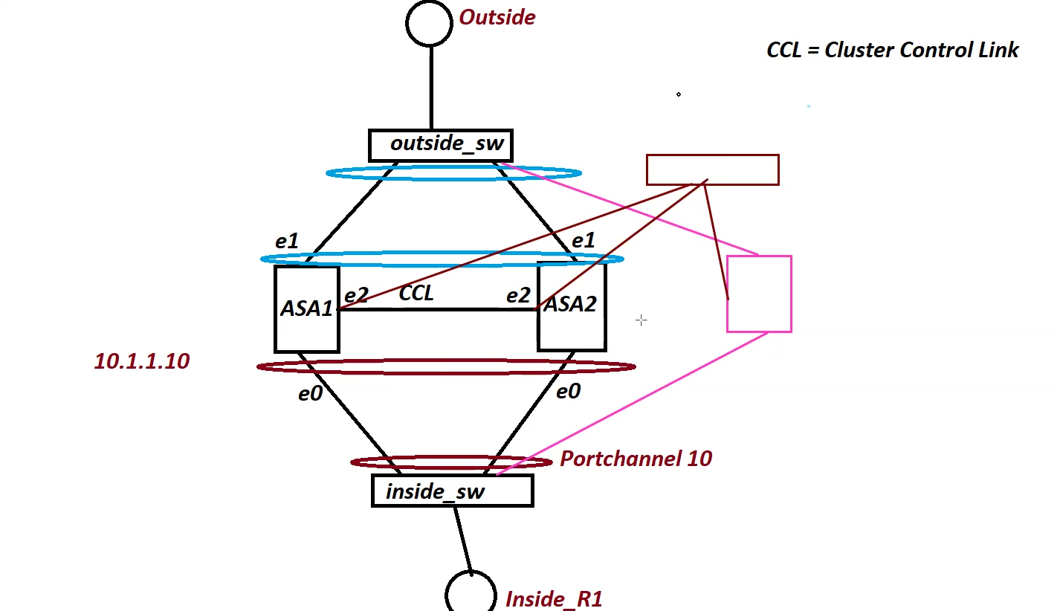

**To which firewall the traffic should be sent is decided by ether-channel  
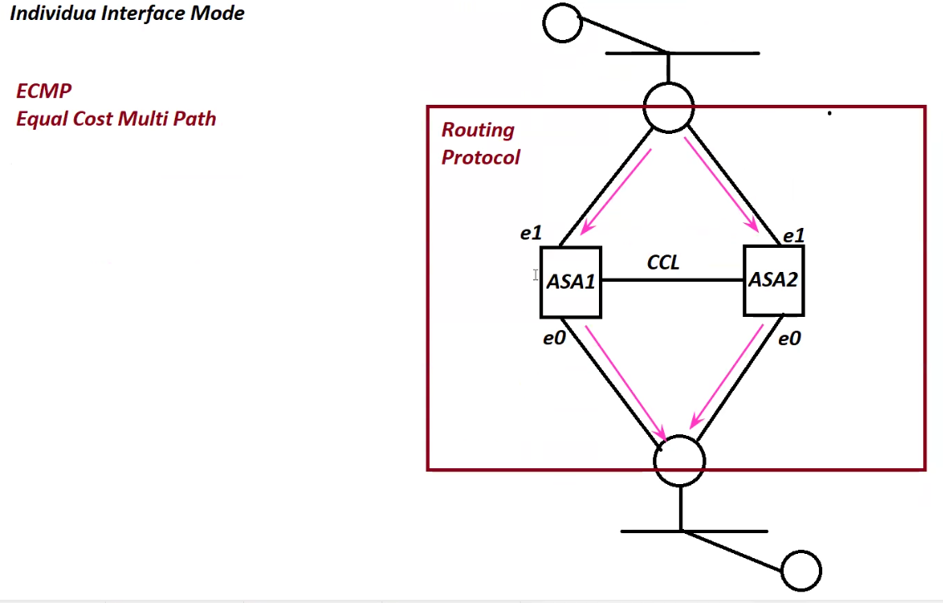  
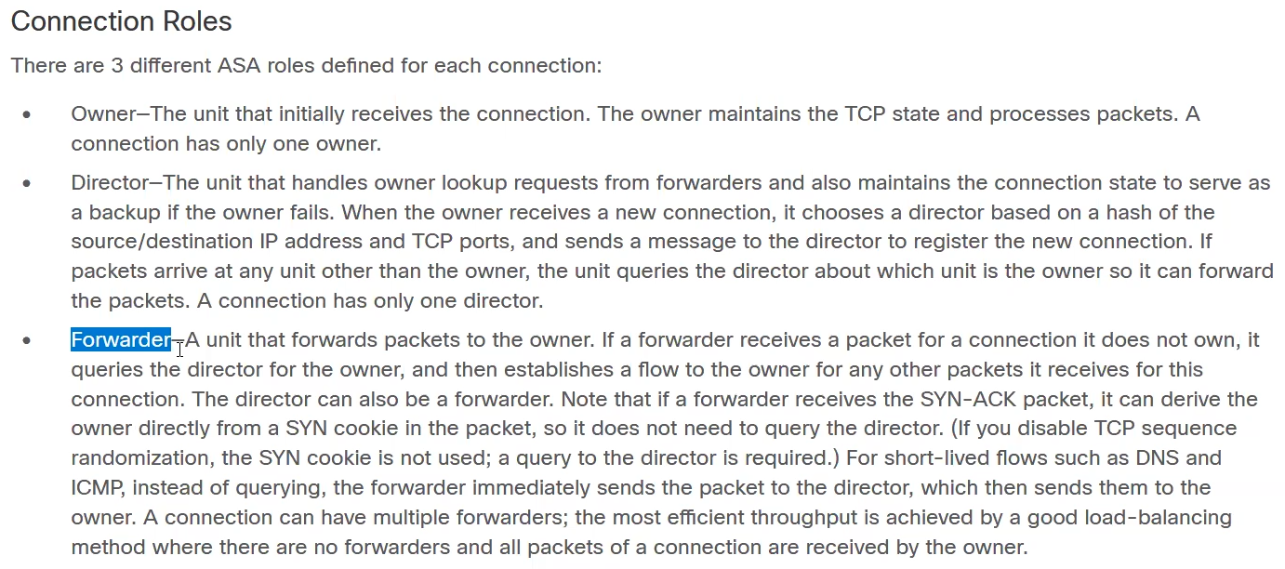  
owner – firewall that receives the first packet.  
director – it stores the connection in the database. If any device asks about connection using arp packet, it will send the owner**

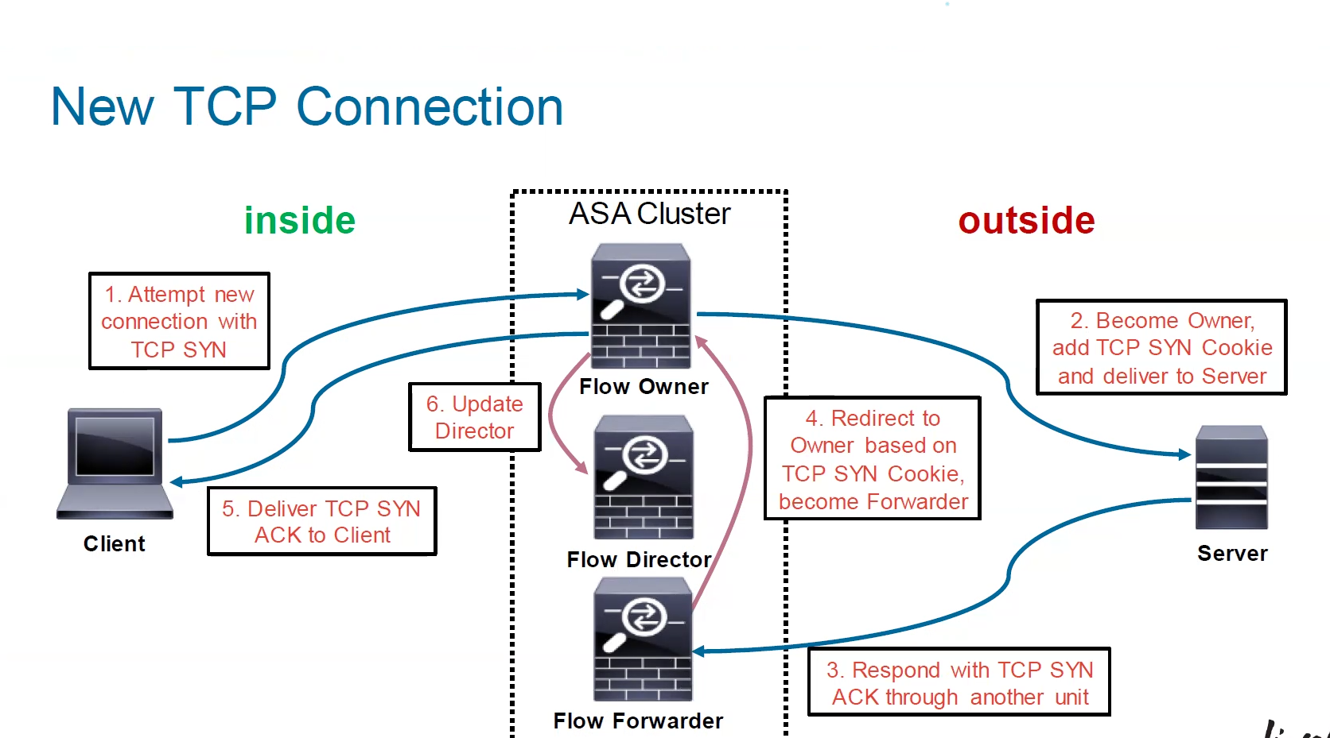

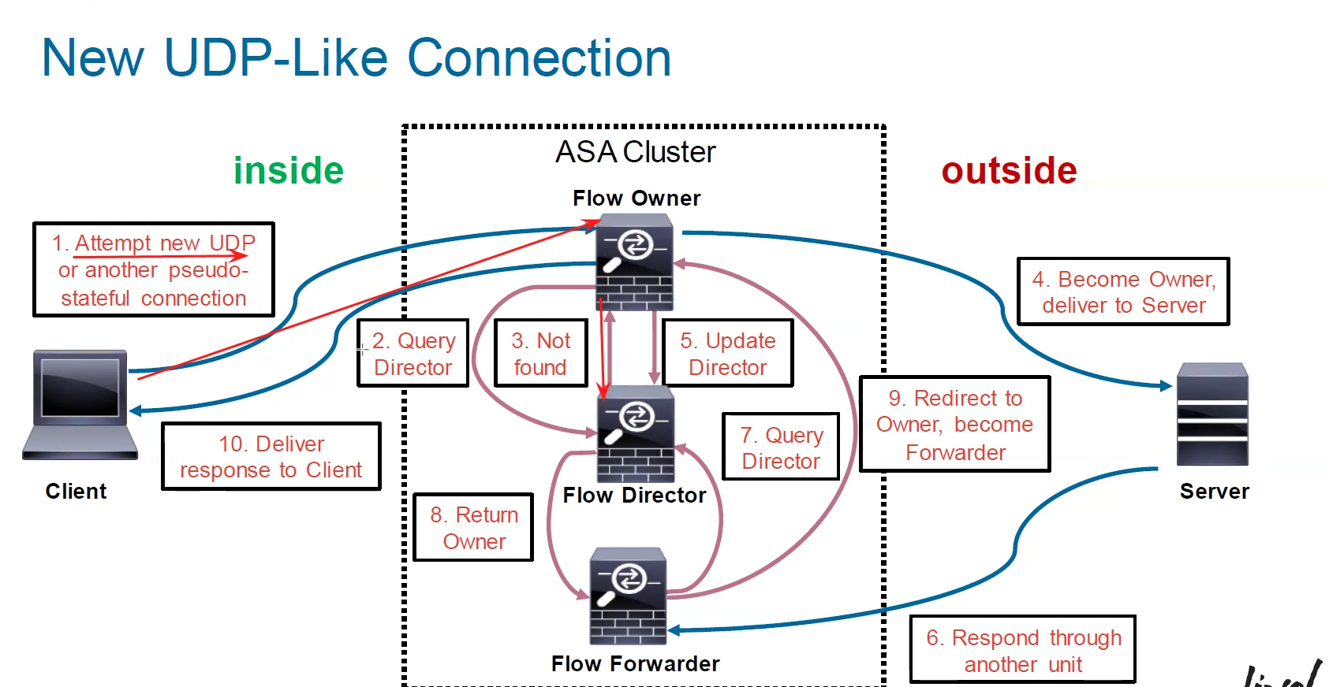

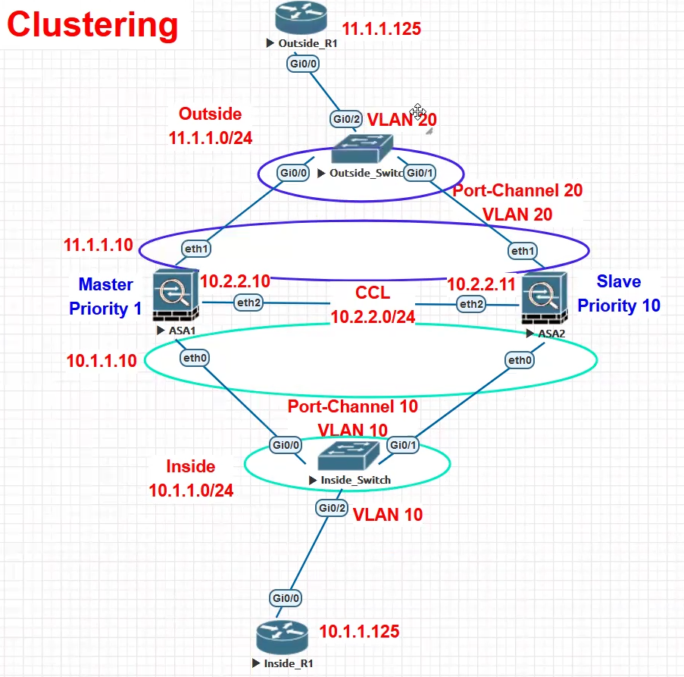

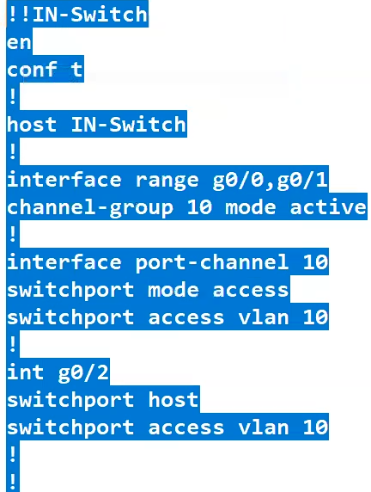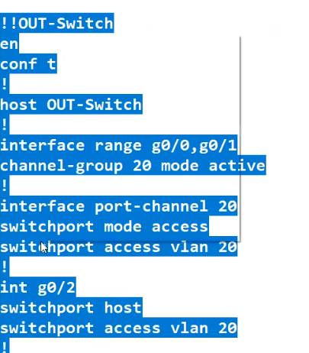

**We need to manually select the master and slave asa.  
one should be master and another one should be slave**

**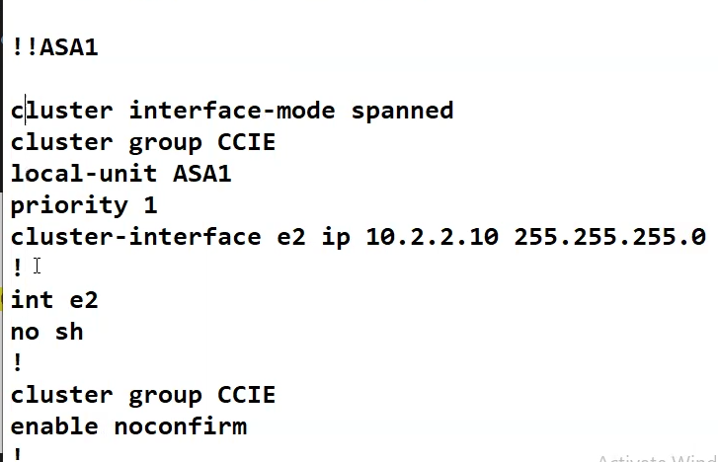  
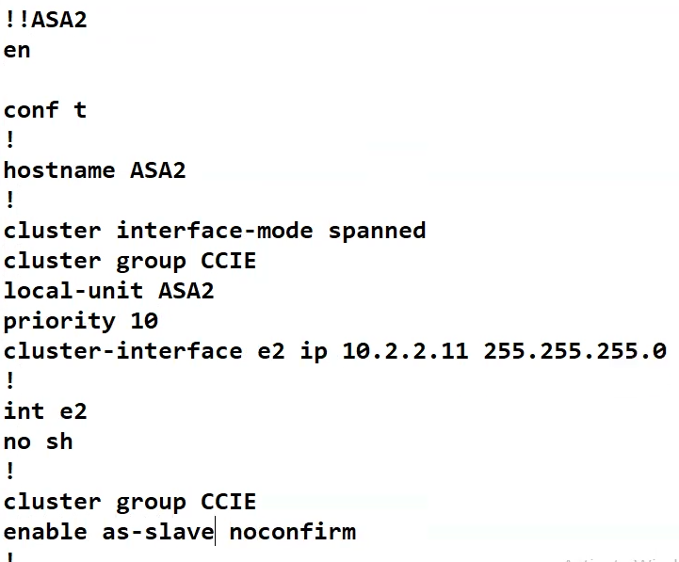**

**In Cisco ASA (Adaptive Security Appliance), clustering refers to the feature that allows multiple ASA units to work together as a single logical firewall. This provides:**

* **High availability (HA)**
* **Scalability**
* **Load balancing**

**It differs from traditional Active/Standby failover by allowing all units in the cluster to be active and processing traffic simultaneously.**

**🔧 Key Concepts of ASA Clustering:**

| **Term** | **Description** |
| --- | --- |
| **Cluster Control Link (CCL)** | **A dedicated interface for cluster member communication (e.g., health monitoring, connection state sharing).** |
| **Cluster Master** | **One unit acts as the master, managing connection state and clustering operations.** |
| **Data Plane Load Balancing** | **Traffic is distributed across members using EtherChannel hashing or load balancing devices.** |
| **Stateful Failover** | **Connection states are synchronized across members.** |
| **Spanned EtherChannel** | **Used to present a single logical interface across multiple ASAs (same MAC address shared across cluster members).** |

**📦 ASA Clustering Topologies:**

1. **Spanned EtherChannel (L2) – Most common in data centers.**
2. **Individual Interfaces (L3) – Each unit has its own IP, requiring ECMP (Equal-Cost Multipath Routing) or load balancers.**

**Configuration:**



